“The Game Boy”
A
Short Film Animation

A Capstone Project
Presented to the Faculty of the
College of Information Technology Education
PHINMA University of Iloilo

In Partial Fulfillment
of the Requirements for the degree
Bachelor of Science in Information Technology

Group:
“Intoxicators”
Members:
Richard H. Pabale Jr
Jasper Red S. Anas
Leemar C. Polancos

April 2026

Approval Sheet
In partial fulfillment of the requirements for the Bachelor of Science in Information Technology, this Capstone Project entitled “The Game Boy” prepared and Submitted by Richard H. Pabale Jr, Leemar C. Polancos, Jasper Red S. Anas. who are hereby recommended for corresponding final evaluation.

Ryan C. Valeriano
Adviser

Approved by the Panel of Evaluators with a grade of PASSED

Dr. Arnold M. Fuentes, Ph. D, MPA, MMIT
Chairman

Andreas V. Armada
Member

Accepted in partial fulfillment of the requirements of the degree Bachelor of Science in Information Technology

Seth dA. Nono, MSCS
CITE, DEAN
Abstract

“The Game Boy” is a short film that gives light on the quiet but powerful ways gaming and computer use can change someone’s life. Set in Modern day, the story follows a young person that got addicted gaming slowly shifts from fun and harmless to something more consuming. Where escaping reality feels better than reality.

The film tells us the character’s life before, during, and after addiction begins, We see changes in routine, appearance, mood, and relationships. Even the small changes can be caused to be impactful too.
“The Game Boy” gives a important questions: What really happens when excessive gaming goes unchecked? Are the effects temporary? do they stay? How do you know when it’s too late?
This film let viewers must reflect on their own digital habits, encouraging balance and awareness in a world that’s everyone uses one. It’s a powerful reminder that even small changes can speak volumes.

TABLE OF CONTENTS

Title page -----------------------------------------------I
Approval Sheet-------------------------------------------II
Acknowledgement-----------------------------------------III
Abstract-------------------------------------------------IV
Table of Contents----------------------------------------V
List of Tables------------------------------------------VI

CHAPTER I

Introduction----------------------------------------------7

Problem Statement-----------------------------------8
Objectives---------------------------------------9-10
Significance of the Study-----------------------11-12
Scope and Limitations---------------------------13-15

CHAPTER II

Related Literature------------------------------------16-19

CHAPTER III

Description----------------------------------------------20

Research Mythology-------------------------------21-22
Qualitative Research--------------------------------23
Research Design-------------------------------------24
Data Collection Methods--------------------------25-26
Data Analysis------------------------------------27-28
Collection Methods----------------------------------29
Tools for Analysis-------------------------------30-31
Cascading Theory------------------------------------32
Project Management-------------------------------33-35
Tangible and Intangible Benefits-----------------36-37
Proposed Budget----------------------------------38-39
Return Of Investment--------------------------------40
Breakdown Of ROI---------------------------------41-42

CHAPTER IV
Synopsis------------------------------------------------43
Overview-----------------------------------------44-46
Script-------------------------------------------47-57
Character Sheets---------------------------------58-60
Staging and Layout used in Scenes----------------61-62
Layout Examples----------------------------------63-65
Camera Angles Examples---------------------66-68
Rough and Cleanup Examples-----------------69-74
In Between Example----------------------------75
Storyboard Examples------------------------76-81
Full Cleanup Example--------------------------82
Background Scenes with Color Examples------83-84
Mouth Chart--------------------------------85-86
CHAPTER V
Conclusion and Summary--------------------------87-88

List Of Tables

Table |  | Page
2x2 | Project Management | 33 to 35

CHAPTER I

Introduction

Our short film, “The Game Boy”, is a part of our Capstone project. This film tells the story of What happens if you keep living in your own fantasy and ignore the reality and the major effect of being addicted to video games. We focus on themes like GAG (Comedy), Man vs Self, and Dangers Of Ignorance. Our Short Film’s art style is western.
The film aims to connect viewers with its story and characters. It deals with Decisions, Immaturity, Personal Conflict, and we hope it connects with a wide audience.
This project allowed us to use our skills in writing, directing, filming, and editing. Every team member played an important role in making this film, from the script to the final edits.
And By the end of Creating this capstone project we will have knowledge and more insights on how to compose or create a short film step by step from creating character’s (based on how many characters you want in a film) , composing script, brainstorming imagine the background of every scene, the camera angles will be using every scene, How many scenes need or needed to be in the film, and lastly the sound, color , and the right editing to make sure everything is on sync or arranged.

Problem Statement

- Context and Background: In recent years, the rise in video game addiction among young people has become a growing concern. With the increasing availability of online games, more students are spending excessive amounts of time gaming.

- Identification of the Problem: The Short film shows the issue of video game addiction and its impact on academic performance among high school students. Excessive gaming has been proved to lower grades, poor time management, and less motivation to study.

- Consequences of the Problem: If left unchecked, video game addiction can lead to significant academic problems, social isolation, and mental health issues. Students affected by this problem are at risk of falling behind in their education (Shown the effects in the short film).

- Justification for the Study: That this short film will not only give you life lessons but also the one key showing the effects of being addicted to video games and what it does to you.

Objective

The short film, “The Game Boy”, explores the impact of video game addiction on a person. This film holds significant value for several reasons:

- Raising Awareness: By showing the struggles of individual addicted to video games, the film aims to raise awareness about a growing issue that is often ignored. It highlights the signs and symptoms of addiction, providing viewers with a better understanding of the problem.

- Promoting Understanding: The film dives into the psychological and emotional challenges faced by someone addicted to video games. By offering a glimpse into their lives, it promotes empathy and understanding among viewers, encouraging them to consider the underlying causes and effects of addiction.

- Highlighting Consequences: Through storytelling, the film illustrates the negative effects of video game addiction, such as poor academic performance, social isolation, and mental health issues. This serves as a story, reminding the importance of addressing the problem early.

- Encouraging Dialogue: The film sparks important conversations about video game addiction among families, educators, and policymakers. By bringing the issue to the audience, it encourages discussions on how to effectively address and prevent addiction.

- Offering Solutions: Alongside finding the problem, the film also explores possible solutions and coping mechanisms. It provides insights into treatment options, preventive measures, and the role of support systems in helping individuals to overcome addiction.

- Educational Tool: The film can serve as an educational resource for schools, community organizations, and healthcare providers. With a relatable and engaging way to educate young people and their families about the risks of video game addiction and the importance of a balanced lifestyle/Habit.

In summary, “The Game Boy” is more than just a narrative; it is a powerful tool for raising awareness, promoting understanding, and encouraging action against video game addiction. Through its thoughtful assessment of the issue, the film aims to make a meaningful difference in the lives of its audience.

Significance of the Study:

Introduction
Our short film, "The Game Boy," is a part of our capstone project. This film tells the story of what happens when an person keeps living in their own fantasy and ignores reality, highlighting the major effects of video game addiction. Through themes such as Personal Development, and Mixing it with Comedy, Free Will, we aim to create a narrative that resonates with viewers.
Importance of the Project:
This study is significant as it explores the growing concern of video game addiction and its impact on personal development and social interactions. By presenting these issues, we hope to raise awareness and promote a better understanding of the consequences of excessive gaming.
Beneficiaries:
The findings and messages of this study will benefit multiple stakeholders:
- Students and Educators: Our film can be used as an educational tool to discuss the effects of addiction and the importance of balancing virtual and real-life responsibilities.

- Mental Health Professionals: Insights from the film can support discussions on addiction and provide a relatable storytelling for therapy and counseling sessions.

- General Audience: Viewers of all ages can gain a better understanding of the potential dangers of video game addiction and reflect on their own habits and choices.

Practical Implications:

"The Game Boy" aims to provide practical lesson by encouraging viewers to reflect on their own behavior with video games and consider healthier lifestyle choices. It’s also serves as a conversation starter for discussions on addiction and mental health.

Theoretical Contributions:
Our project will contribute to the existing knowledge by providing a creative exploration of addiction and its psychological and social effects. It adds to the impact of digital media and virtual realities on personal development and free will.

Social Impact:
By addressing the issues of addiction and personal conflict, our film has the potential to influence positive change in society. It encourages viewers to seek balance in their lives and to be mindful of the time spent in virtual worlds versus real-life interactions.

Future Research Directions:
Future research can build on our project by exploring the long-term effects of video game addiction. Additionally, studies can investigate how different storytelling approaches and art styles impact the audience's perception of addiction and personal development.

Scope And Limitations:
Scope:

- Focus on Video Game Addiction:

- The short film Focuses on the issue of video game addiction, particularly among adolescents.

- It explores the causes, symptoms, and consequences of addiction.

- The narrative highlights the impact on academic performance, social relationships, and mental health.

- Target Audience:

- The film is intended for a broad audience, including teenagers, parents, educators, and policymakers.

- It aims to raise awareness and promote understanding across different age groups and societal roles.

- Educational Component:

- The film serves as an educational tool, offering insights and knowledge about video game addiction.

- It can be used in schools, community programs, and awareness campaigns.

- Emotional Engagement:

- Through storytelling and character development, the film aims to give empathy and emotional engagement from the audience.

- It seeks to encourage viewers to reflect on their own experiences and behaviors.

Limitations:
- Duration:

- As a short film, the narrative is held by time, limiting the depth and clarity of the story.

- Some aspects of video game addiction may not be fully explored due to time constraints.

- Representation:

- The film focuses on specific characters and situations, which may not represent all experiences of video game addiction.

- Individual experiences with addiction can vary widely, and the film may not cover every perspective.

- Simplification:

- To fit within the short film format, complex issues related to addiction and its impact might be simplified.

- The film may not dive into all the conflicts and detailed psychological aspects of addiction.

- Generalization:

- The story may generalize certain aspects of video game addiction, and viewers’ experiences may differ.

- The film might not address all cultural, social, and individual differences in addiction experiences.

- Resources and Budget:

- Production limitations, such as budget and resources, may affect the quality and scope of the film.
- Certain desired effects, locations, or professional talent might be restricted due to financial constraints and equipment capability.

CHAPTER II
Related Literature

Introduction
Short stories are a powerful way to raise awareness because they present real issues in a form that is easy to understand and connect with. Through characters and simple plots, they can show the struggles people face and the lessons that can be learned. In this study, the short film “The Game Boy” was created to highlight the effects of video game addiction. By using storytelling and animation, the project aimed to show how gaming can affect emotions, relationships, and personal growth.
This idea is supported by Clark and Scott (2009) in their book Game Addiction: The Experience and the Effects, where they share real cases of how gaming can strongly influence behavior and decision-making (p. 1). Their work shows that gaming addiction is not only a personal issue but also a social concern that needs more attention. By combining research with creative storytelling, this project hopes to make the audience more aware of the impact of gaming addiction in everyday life.
Reference:
Clark, N., & Scott, P. S. (2009). Game addiction: The experience and the effects (p. 1). Jefferson, North Carolina: McFarland & Company, Inc., Publishers.
- Authors: Neils Clark & P. Shavaun Scott
- Publication Year: 2009
- Publisher: McFarland & Company, Inc., Publishers
- ISBN: 9780786443642
- Page Referenced: Page 1
- Topic Covered: Real-life cases of gaming addiction and its psychological impact

Conclusion:
The review of related literature and studies highlights the significant impact of video game addiction on various aspects of life, particularly academic performance and mental health. By addressing/showcasing these issues in our short film, we aim to raise awareness and promote understanding among viewers.

CHAPTER III

DESCRIPTION

"The Game Boy" is a short film that serves as the essential piece of our capstone project. It dives into the story of an individual who becomes deeply engrossed in the world of video games, leading to a life where fantasy overshadows reality. As the protagonist grapples with the consequences of his addiction, he faces significant personal conflicts and tough decisions that challenge his immaturity and sense of free will.
Through its engaging narrative and developed characters, "The Game Boy" explores themes of personal development and self-Ignorance. The film highlights the importance of finding a balance between virtual escape and real-life responsibilities, showcasing the major effects of excessive gaming on one's life and relationships.
The western art style adds a unique visual element to the film, enhancing its storytelling and emotional impact. By focusing on the protagonist's journey of self-discovery and growth, "The Game Boy" aims to resonate with a wide audience, encouraging viewers to reflect on their own habits and the choices they make in their lives.

Research Mythology:

- Research Title:

“Short Film Survey"

- Research Objectives:

To see what their response upon watching the short film that we composed by creating a survey.

- Research Questions:

- Are you satisfied with the ending?

- Rate on our Animation.

- Are you satisfied with the way the story progresses?

- Rate on characters.

- Rate the way we place backgrounds, camera angles, and compositions.

- Rate on how you understand the story.

- Design and Method:

We used a qualitative creative approach, merging visual arts with thematic exploration. The study took shape through:

- Scriptwriting and Pre-visualization: using Microsoft Word and Krita to map story flow, character development, and emotional beats.

- Animation Execution: with pen tablets and Krita software, translating static visuals into movement that reflects the character’s internal journey.

- Post-Production and Scene Arrangement: using CapCut and Microsoft Clipchamp to refine timing and emotional delivery through reenactments and visual contrast.
5.Sampling and Collaboration:
- Our small team, consisting of student artists and editors, collaborated closely sharing ideas, refining storyboards, and adjusting frames for emotional accuracy. Everyone brought a personal lens to the theme, which added authenticity.

6. Reflection and Analysis:
- Throughout the process, we reflected on how each scene aligned with our real-life observations of screen overuse. Choices in lighting, pacing, and framing weren’t just technical, they were intentional emotional cues. Editing became a tool not just for clarity, but for compassion.

Qualitative Research: Observational Mythology

In today’s hyper-connected world, screen habits have quietly reshaped daily life—and “The Game Boy” was created to reflect that changes. As part of this research, we aimed not only to tell a story but to observe how others receive That story. Through qualitative observation, we explored how audiences emotionally and physically responded to the film’s themes of digital addiction, and behavioral changes.
This approach allowed us to look beyond scripted feedback and capture real-time reactions and facial expressions, body language, whispered comments, even moments of long term silence. Did viewers lean in during key scenes? Did they nod, fidget, or laugh nervously when something resonated? These subtle clues spoke volumes about how the film’s message landed.
We focused on how viewers processed the contrast between "before”, “During”, and "after" the main character’s subdued into Addiction. The goal wasn’t to judge responses, but to understand how different individuals interpret the same visual clues based on their own experiences.
By observing audiences in shared spaces, whether classrooms, digital forums, or private screenings, we collected insights that go beyond surface-level opinions. These observations help reveal the emotional effectiveness of our storytelling—and underscore the very real ways media can spark reflection and dialogue in today’s digital landscape.

Research Design – Phenomenological Approach

This study focuses on how viewers personally experience “The Game Boy”. Instead of just counting who liked or disliked the film, we wanted to learn what it meant to each person and why.
We looked for reactions around these themes:
- Personal growth
- Free will and choices
- Immaturity
- Decision-making
- Inner conflict
Screenings were held in small groups and one-on-one settings. We paid attention to both what people said and how they acted—smiles, frowns, body language, and pauses. These moments helped us see how the film affected them emotionally and mentally.
This approach goes deeper than simple feedback. It shows how the story stayed with viewers, made them reflect, or sparked conversations long after the credits rolled.

Participants:
The study involves a diverse group of participants, including students, educators, mental health professionals, and general viewers. A purposive sampling method is used to select participants who are representative of the target audience for the film.

Data Collection Methods:

- Observation Setting:

- Observations are conducted in a controlled environment where participants watch the film. This setting ensures that all viewers have a similar experience and that their reactions can be accurately recorded.

- The observation takes place in a screening room equipped with audio-visual recording equipment to capture both visual and auditory responses.

- Observation Techniques:

- Non-Participant Observation: The researcher observes the participants without interacting with them, allowing for natural and unbiased reactions.

- Structured Observation: A observation checklist is used to systematically record specific behaviors and reactions of the participants during the film screening.

- Field Notes: Detailed field notes are taken to document the context, environment, and any noteworthy observations that occur during the screening.

- Observation Checklist:

- Emotional Reactions: Note any visible emotions displayed by participants (e.g., laughter, tears, smiles, frowns).

- Engagement Levels: Record instances of participants' engagement (e.g., leaning forward, focused attention, verbal comments).

- Body Language: Observe body language cues such as posture, gestures, and facial expressions that indicate participants' reactions to specific scenes.

- Social Interactions: If participants are watching the film in a group, note any interactions or discussions that occur during or after the screening.

- Open Forms Survey

- Google Forms: By creating a google form survey we can determine on thier perspective and reactions on our short film

- Tools Used:
- Google Forms – for creating and sharing the survey

6.Output:
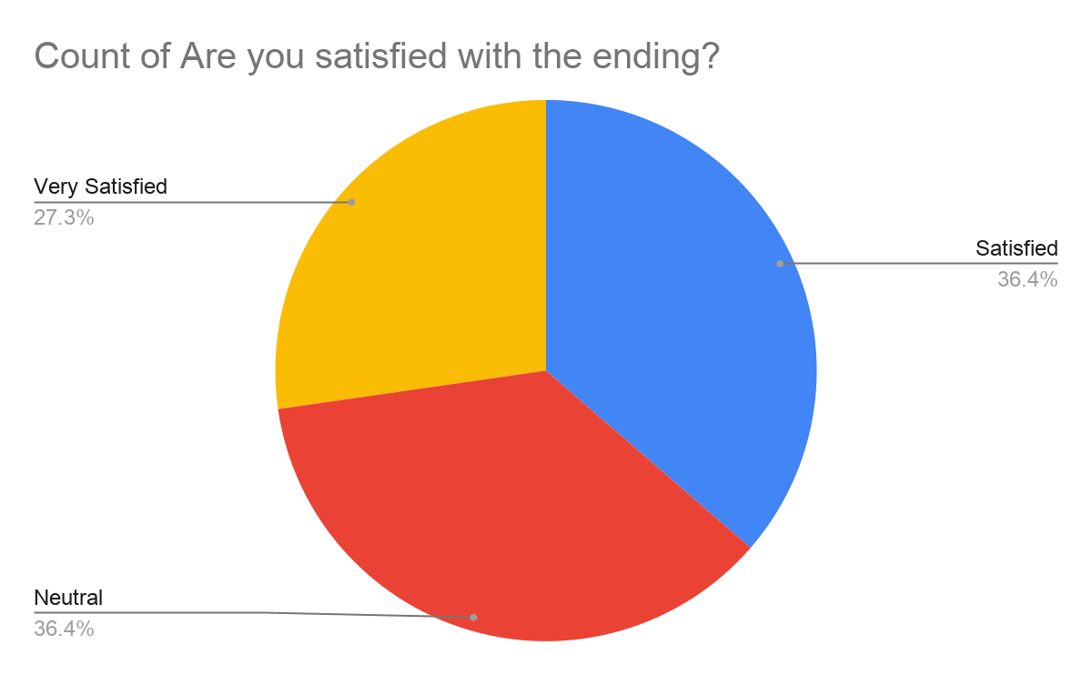

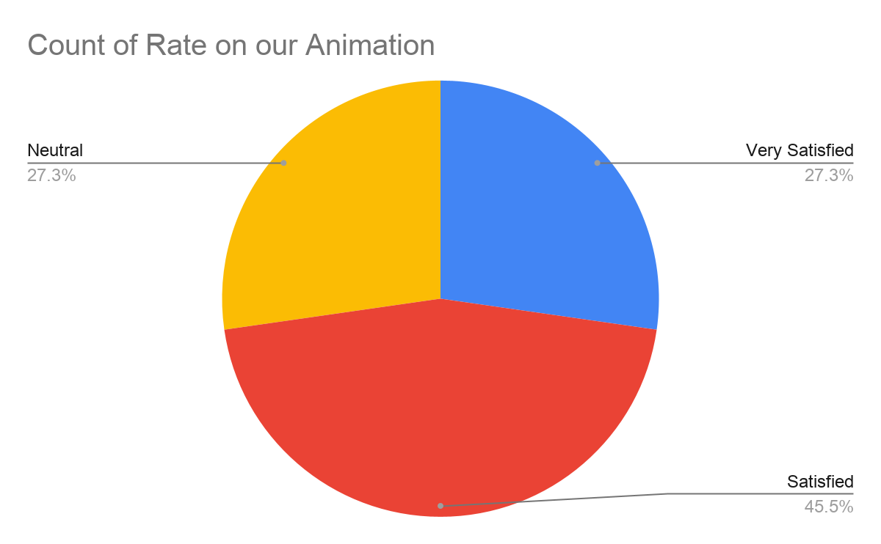
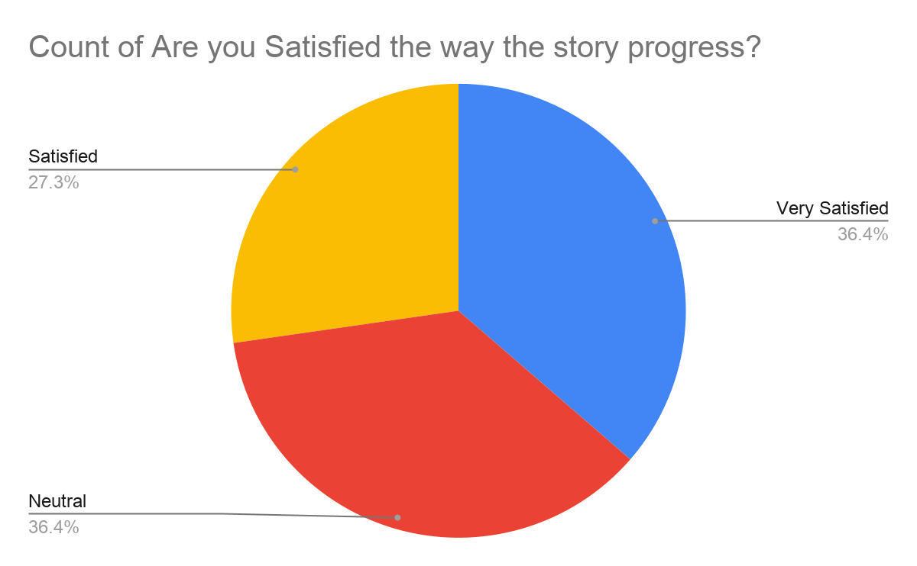
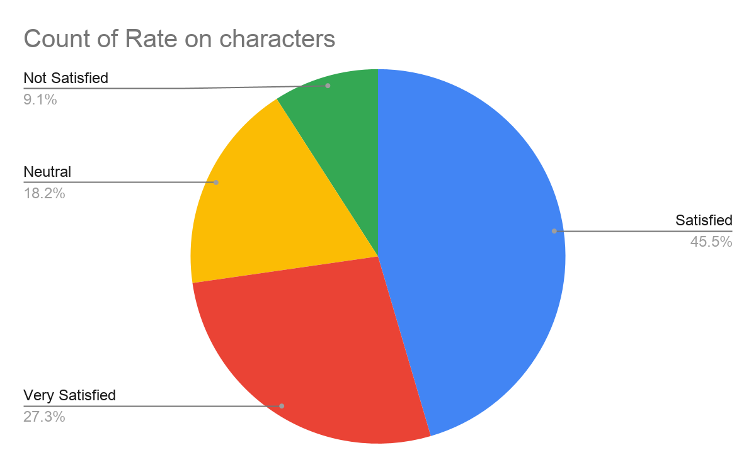

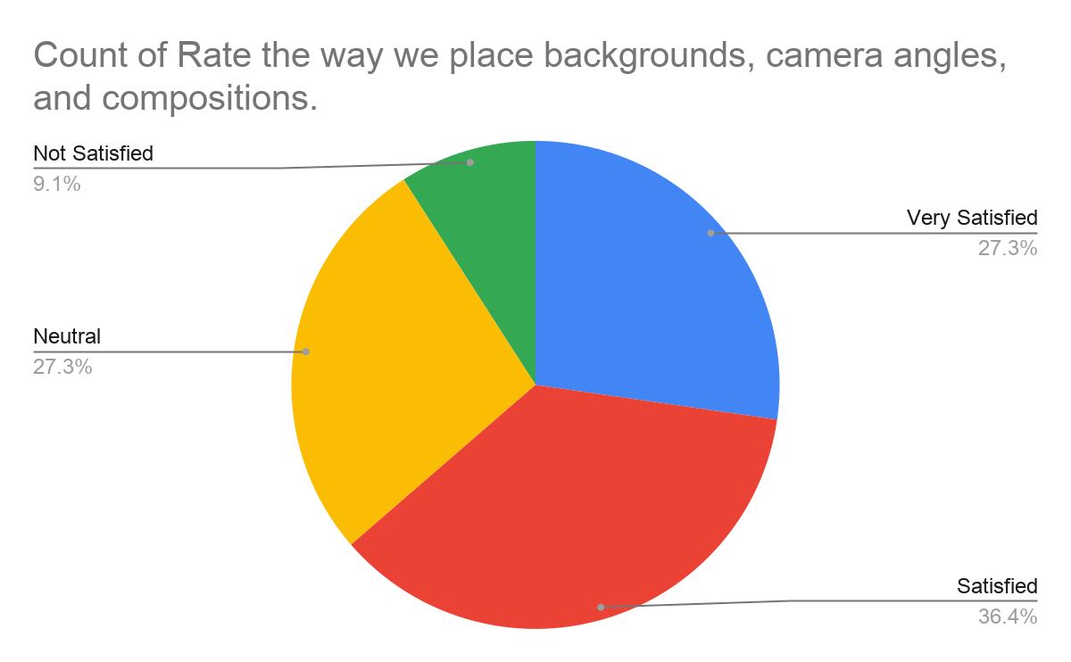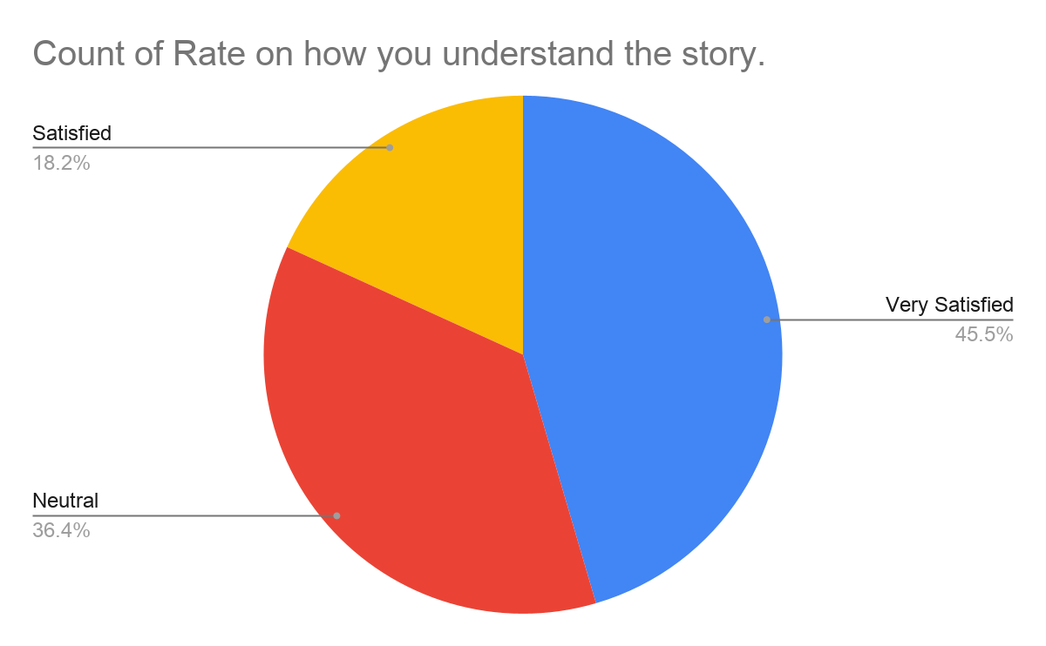

Data Analysis

- Coding and Categorization

- The recorded observations and field notes are reviewed and coded to identify significant behaviors, reactions, and patterns.

- Codes are grouped into broader categories that reflect key themes and areas of interest.

- Theme Identification

- The categorized data is analyzed to identify recurring themes that capture the essence of participants' experiences and interpretations of the film.

- Themes are reviewed and refined to ensure they accurately represent the observed data.

- Interpretation

- The identified themes are interpreted in the context of the study's objectives and theoretical framework.

- Connections are made between the observed reactions and the broader implications of the film's themes and messages.

Ethical Considerations:

- Informed consent is obtained from all participants before the observation begins.

- Participants are assured of confidentiality and anonymity in the reporting of the study's findings.

- Ethical approval for the study is obtained from the relevant institutional review board.

Conclusion:
This qualitative research provides valuable insights into the impact of "The Game Boy" on its audience through observational methods. By capturing real-time reactions and behaviors, we aim to highlight the significance of the film's themes and messages. The findings contribute to the closure on video game addiction, personal development, and the influence of creative media on societal issues.

Collection Methods

As for collection methods ill list down the collection methods I used to ensure the data collection and understanding of animation like tools, and applications.
Addition to that their names and their details placed in every labeled names or how they work to help me understand more about digital animation.

Collection Methods:
- Script writing: This is the part where every scene and their actions(Laughing, walking, running, eating, and etc), locations ( Park, house, school, train, bus, etc), time of the place (Day,Noon Night), camera angles (Wide shot, Medium shot, Close up shot, Extreme close up shot), backgrounds, and lastly their dialogue are placed here and labeled each one of them from the beginning up to end of the scenes.

- Storyboarding: The panel where every scene has their perspective picture/drawing of each scene that looks like preview of scenes so that you are aware on what’s happening on that scene. In addition to that there are also details of the scene like scene number, description, dialogue, action, and lastly camera angles.

- Reenactment and Key framing: For the movements of every character we use the methods of reenactment and key framing. On reenactment every scene we recreate by filming our-self those actions and align the angle so that we have a guide and also know where we start and
finish the key fame and the breakdowns of movements.

- Google Forms Survey – We created a survey using Google Forms with open-ended questions. This allowed participants to share their thoughts freely. The questions focused on their gaming habits, feelings, and how gaming affects their daily life. Using Google Forms made it easy to collect and organize responses.

Tools For Analysis

- Animation Software: From this part we used only two application to help us finish our animation project they are Krita, and Blender. These two application helps us to create, visualize, and apply animation that helps us finish our Short film project. Krita Helps us to create storyboard, animate, and make backgrounds for our short film, Meanwhile the Blender helps us by recreating the background in our storyboard in 3D models so that not only we have a clear visualization of the background but also we can create any angles with ease due to we have a 3D model of the background.

- Editing and Composition Software: Through video editing and composition we been able to mix the scenes and compile them together, in addition we also added music character voices and background noise to the compiled video which makes the finish product better we used Capcut, and Microsoft Clipchamp for editing purpose.

- Data Visualization Tools: The use of it makes the animation smoother to be exact by adding rendering, frames, timing, file sizes, and more.

By implementing these methods, it helps greatly especially in capstone project of ours which is a digital animation. In addition it also helps make the overall Animation smooth, clean, have a timing, and not blur or crappy.

Selection Process of digital tools:

As a essential and important part of completing the capstone project are the tools need to create a digital animation. These tools have their uses and their importance/role on completing the project. The Selection of Krita, Capcut, WPS office, and Blender. We will breakdown each tool and their significance and how are they important.

Significance of Krita:

- Versatility: Krita offers a lot of selection of tools which can be use for free and you can also create, animation, storyboard, drawing, and etc. Every tools and functions Krita has it helps greatly.

- School Standard: Krita is a school recommended tool for animation, drawing, storyboarding, and even editing. Since it’s a user friendly application due to its easy to learn and use of tools and function built in the application.

Significance of Capcut:

- Editing : We use the Capcut to mix, edit and apply the essentials needed to complete our Capstone project Which is a Short Film Animation. The examples are, Adding sounds of music, voice, and other needed sounds. In addition we follow a file resolution like a border with the help of Capcut we able to resize the file to its desired size or required size like 1920 1080px size. Of course don’t forget that we able to complete our capstone project by compiling the file we create into one so that ill be into one file and alsowith help of Capcut we’ve been able to synchronize every scene which first to last.

Cascading Theory

Cascading Theory describes how a small change or action can set off a chain reaction, growing larger and more impactful over time. It’s like dropping a pebble in water: the first ripple is tiny, but it quickly spreads across the whole pond.
We apply this theory to The Game Boy because it mirrors the film’s journey:

- A few extra hours of gaming seem harmless at first.

- Those late nights begin to affect sleep and focus.

- Diminishing sleep hurts academic performance and mood.

- A worsened mood leads to isolation and stress, which drives even more gaming.

Each step feeds into the next, creating a loop that turns small habits into major life disruptions. By using Cascading Theory, our animation shows how one “harmless” change can magnify into physical strain, mental health challenges, and academic decline—highlighting the real-world power of tiny habits gone unchecked.

Project Management

Title: “The Game Boy”

The main goal of this objective is to show a Short film about What does excess use of computer games using it to play games affect your life from before getting addicted to getting addicted like “before and after the disaster” like message. Since it’s a Short film we will list down our progress like post production and its duration to final touches and presentation.

Pre Production - (2 weeks) | What Did We Do And with description:  Brainstorming of title, what will be the story, and its characters creation:  (1 day) on that period we come up with the story what should be the story is all about the events settings, characters, scenes, and their roles.  Scriptwriting: (3 days) on this 3 days of developing the detailed script of the story itself from start, mid, and end. Also added there was the detailed version of the story from every scene no, time, day action, camera angle, character involved, their script/dialogue, and lastly the background/ setting the scene will be happening.  Character Development/Creation: (2 days) on the 3 days the complete developing or creating the characters involved in the story ( we only include the important). From their appearance to their info like name, age, gender, and etc.  Reenactment (1 day) : This day where we re-create the movements of specific characters scene by scene via video recording. We also match the camera positioning, angle, and how far or close it is to the object based on that scenes, so that we will have clue or guide on in between of the movements in the characters.
Production Scenes (9- 11 weeks ) | Storyboarding (3 Weeks) : Creation of storyboard with description of the scenes with their respective preview drawing each one of them with small details like day, location, short description, character involved, with their dialogue and actions, and lastly the camera angle.  Animation ( 6 weeks if no class 8 weeks if there's class to attend) : The part where the beginning of creation of animation or animating all the scenes followed on both storyboard and script where we follow it strictly based on those two.
Post Production ( 6 weeks) | Sound Design and creation (2 weeks):  Implementation of background music, like the songs, ambiance, etc.  Voice Over Dub recording (2 weeks): Crucial part of the animation Where any thing on the description on what a character should say will be recorded and apply on the short film of course the voices are meant to match on what scene they are present.  Editing (2 weeks) : Compiling everything into one short film by combining all scenes, sounds, voice overs, and their arrangements.
Final Touches and presentation (2 weeks) | Documentation (1 week) : The documentation of all things related to the capstone project from the overview to every detail needed like progressions , goals, target audience, duration of the creation of capstone project, etc.  Presentation (1 week) : The final week where everything Is finished and arranged well the only thing left to do is to present it.

Tangible and Intangible Benefits

The following list below are the tangible and intangible things we earned while making our capstone project: [The Game Boy] A Short film Animation.

Tangible Rewards :
- Portfolio Piece: A completed short film adds a significant project to the professional portfolio, showcasing skills to potential employers or clients.

- Educational Credits: If this is a school project, our group/team will earn academic credit and potentially achieve a high grade or distinction.

- Job Offers: A successful project might attract job offers or internships from studios or companies impressed by your work.

Intangible Rewards:
- Skill Enhancement: Upon completion our team/group gain valuable experience and improve most of our technical and creative skills in animation, storytelling, and project management.

- Personal Growth: Completing a significant project can boost the group’s confidence, resilience, and sense of accomplishment.

- Creative Fulfillment: Bringing the vision our group created to life and sharing it with an audience can be deeply satisfying and fulfilling.

- Critical Thinking and Problem Solving: Overcoming challenges during the project will enhance our ability to think critically and solve problems effectively.

- Reputation Building: Establishing our group as a capable and talented animator can enhance professional reputation.
Proposed Budget

Even though we barely used money during our journey so far on finishing our capstone project we will still showcase our annual spending from pre-production to the current production phase since our progress is still ongoing.

Pre-Production:
- Concept Creation: ₱100 (bond papers used, pencils, and yellow paper used during this phase.

- Scriptwriting Prototype: ₱350 (used a whole Drawing pad to create ideal story script for the animation).

- Character Creation: ₱350 (Buying a drawing pad for the character creation).

- Storyboard Creation : ₱350 (Separate drawing pad for the creation of different scenes finding the appropriate drawing of scene for the storyboard).

Production Stage:
- Public Transportation fee meetup and going home: ₱150 (Total spending from our 3 separate transportation fee going to our workplace to going home).

- Snacks and Meals : ₱1,000 (Our total of spending in a month from buying Breakfast, lunch, and Rest time meals to keep our energy and also avoid getting hungry.)

Post-Production Stage:
- Misc Spending : ₱1,000 (From the capcut Premium subscription for more editing freedom to other unexpected spending.)

Final Touches and Presentation:
- Printing of Documents : ₱600 (Total of Payment on printing the documents for the capstone project).

- Snacks for the panelist : ₱100 ( The donation for the panelist meals).

(ROI) Return Of Investment:
Advance disclaimer! Since our project is purposely For school submission we will place a different return of investment.

Intangible ROI:

- Skill Development: The experience and skills we gain during the project are invaluable. This includes technical skills in animation, storytelling, teamwork, and project management.

- Portfolio Enhancement: Our group completed project serves as a showcase of your abilities, which can be a crucial asset when applying for jobs or further education.

- Networking Opportunities: Collaborating with peers, mentors, and industry professionals can open doors for future opportunities and collaborations.

- Academic Achievement: Successfully completing the project can lead to good grades, accolades, and recognition within academic institutions.

- Creative Fulfillment: Bringing the creative vision to life and sharing it with an audience can be deeply satisfying and fulfilling.

The Breakdown of ROI:

- Skill Development:
- Technical Skills: Animation techniques, software proficiency (e.g., Adobe After Effects, Blender).

- Creative Skills: Storytelling, character design, visual aesthetics.

- Project Management: Time management, task prioritization, collaboration.

- Portfolio Enhancement:
- Project Showcase: High-quality work to demonstrate your capabilities to potential employers or clients.

- Diverse Skills: Showcasing a range of skills (e.g., animation, writing, directing).

- Networking Opportunities:
- Collaborations: Working with peers, instructors, and possibly industry professionals.

- Professional Contacts: Building relationships that may lead to future job opportunities or partnerships.
- Academic Achievement:
- Grades: High marks contributing to overall academic performance.

- Recognition: Awards or accolades within your academic institution.

- Creative Fulfillment:
- Personal Satisfaction: Achieving a creative vision and sharing it with an audience.

- Emotional Expression: Conveying themes or messages that are important to you.

- Critical Thinking and Problem Solving:
- Challenges: Overcoming technical and creative obstacles.
- Learning: Gaining insights into the animation process and improving problem-solving skills.

Chapter IV

Title: The Game boy
Synopsis:
What happens when the screen becomes more comforting than real life?
“The Game Boy” is a deeply personal short film that follows a teenager caught between two worlds—one filled with pixels and power-ups, the other with people and responsibilities. At first, gaming is just a way to unwind. But Shifted into a addiction That drastically changed his life.
This isn’t a story about villains or warnings—it’s about choices. About how easy it is to lose yourself when the digital world feels safer than the real one. Through raw emotion, quiet moments, and a western-inspired art style, the film explores addiction not as a monster, but as a shadow that grows when no one’s looking.
As the protagonist faces the consequences of his missed opportunities, strained relationships, and a growing sense of isolation—he’s forced to confront the question: Is it too late to come back?
“The Game Boy” is more than a tale. It’s a mirror held up to anyone who’s ever felt overwhelmed, disconnected, or tempted to disappear into a screen. It’s a story of Maturity, and the power of choice—even and how it can change some minor into major thing even with consequences.

Title: The Game Boy

Overview:
The Game Boy is a short film that makes you learn and know the consequences if you get addicted into gaming. The story progresses and follow the points below.

Act 1: Introduction
-The story begins with The protagonist playing games in the middle of the night in his room, When suddenly a frying pan flew across the him, he dodges it but upon dodging realizing the trajectory of the pan before he knew it hit the computer which led to the computer screen being broken. In effect he just cried.
-Shifted to morning and Showcased the house of the protagonist,
-Where the alarm sounded and he wakes up signaling he will be going to school.
-Navigating Though kitchen to eat upon seating he proceeds to eat.
-After Eating the scene switch to him going outside to go to school, when he opens the door his friend Jamal greeted him outside his house.

Act 2: Journey
-The Scene was switched to the alley where the chatted a bit.
-Jamal after a bit of talking urged Luka the protagonist to go to a local computer café to play instead of going to school.
-And Luka upon hearing it just agree and heads to the local computer café.
-Upon arriving They enter the café and proceeds to be seated to start playing.
-They started playing intensely like laser focused into the game, they won. As a celebration they have a high five.
-They played and played again until you see the time fly too fast until its night time.
Act 3: Climax
-Switched to nighttime = Luka having the time of his life overplayed and got home very late at night.
-He was slowly going to enter since he got home very late at night and he might got scolded because of it,
-So he did is slowly open the door and peek and see if there’s someone waiting for him. After conforming there’s not he proceeds to go inside and sneak like a ninja.
-But wait he hears something as he turn his head to look, There it is his mom on a sofa chair actually waiting for him.
-But after he knew his sneaky tactic fails he just walk normally and proceeds to go to his room and sleep.
-As he lays on the bed he slowly closes his eyes.
-When suddenly he was surprised because we has in a different place. He saw a bridge with two pathways, one with a diploma, and the other with a chest.
-Luka however walked into the chest. As he picked it up suddenly, the rope got cut and together with the bridge they both collapse into the river ending his dream.
-Suddenly he woken up on his nightmare.
-After that he proceeds to go to school but still bothered but what he dreamed last night.
-As he navigated to school he stumbled onto Jamal, and as they talked about going again, but this time he refused due to he needs to attend to class. And they separate ways for now.
-Switched to his classroom, as he thinks suddenly he saw something on the board as he looked into it it’s a announcement for upcoming exam which is tomorrow.
-After that class he heads home but he stumble again on Jamal but this time looks like Jamal was waiting for him.
-They greeted each other but Jamal has other plans. He peruse Luka to play with him and he accepts it.
-They headed to the computer café and straight to play. As they play they lost 1 game, but Jamal ask for another game, and they both go with it not noticing the time.
-Once again he head home very late at night after he heads home he just straight throw his bag and sleeps and forgets about the exam for tomorrow not knowing he needs to review.
Act 3: Resolution
-The nest day he headed to school without any review whatsoever so he takes the exam with empty knowledge about it.
-Throughout filling out the test paper he was actually scrambling on what to fill as he fill the blank time passes by until he didn’t notice that its time to pass but his paper was still missing some tings. On frustration he just grip his pen and smash it, but with no other choice he pass his paper.
-After Checking and the results were in as he goes forward and gets his paper.
-Now that he receives it he looks at it and it reveals he did terrible and actually got the worst score possible, on his shocked he just got the look on his face of shocked and surprised. END

The Game Boy
Script
FADE IN:
INT.BEDROOM-NIGHT
Luka was playing a game on his personal computer in the middle of the night.
INT.BEDROOM-NIGHT
As he clicked the mouse like a maniac.
INT.BEDROOM-NIGHT
Hovering his mouse smoothly.
INT.BEDROOM-NIGHT
The look on his on how he is immersed playing the game.
INT.BEDROOM-NIGHT
When suddenly a frying pan was seen flying across him and looks like the trajectory of the object is towards him.
INT.BEDROOM-NIGHT
He heard it and saw the pan on his instincts he dodged.
INT.BEDROOM-NIGHT
He dodged it no sweat like its nothing.
INT.BEDROOM-NIGHT
As the pan slowly making its way on his face Luka noticed the direction of the pan.
INT.BEDROOM-NIGHT
It was in the same direction on the computer it was too late to notice and it was crashed into the computer screen resulting in cracking of screen.
INT.BEDROOM-NIGHT
The look oh Lukas face as he realized that his personal computer is now broken.
INT.BEDROOM-NIGHT
In effect he just cried.
CUT TO:
EXT.HOUSE-DAY
Next day comes as the day rises the house of the protagonist was shown.
CUT TO:
INT.BEDROOM-DAY
The fans were rotating as if it showcasing the top view of his room.
INT.BEDROOM-DAY
The alarm was shown and into the time 7:00 the alarm clock activates and shakes.
INT.BEDROOM-DAY
After he heard the alarm he slowly opens his eyes to wake up.
INT.BEDROOM-DAY
Gets up from his bed
CUT TO:

INT.KITCHEN-DAY
After he gets up the bed then proceeds to navigate through the kitchen to dining table to eat.
INT.KITCHEN-DAY
As he stops and looks for a seat, he sees something he was surprised to see.
CUT TO:
INT.DINING ROOM-DAY
He sees a empty table and chairs but with a food already placed there like it’s meant for him.
INT.DINING ROOM-DAY
After That he headed to sat down and eat so that after he finished eating, he will be heading to school.
CUT TO:
INT.MAIN HALL ENTARNCE-DAY
Now that he was done eating, he straight head outside.
INT.MAIN HALL ENTRANCE-DAY
As he opened the door and headed outside, he saw something waving from him outside of his house.
INT.MAIN HALL ENTRANCE-DAY
Upon closer look, it’s his friend Jamal that was waiting for him outside his house.
CUT TO:
EXT.NEIGBOURHOOD STREET-DAY
Walking together navigating the streets, While chatting They decided to head to a computer shop instead of heading to school.
CUT TO:
EXT.HIGHWAY STREET-DAY
So, they headed to the destination they wanted so they did a little detour.
EXT.HIGHWAY STREET NEAR PERDESTRIAN-DAY
They stopped on a pedestrian to look up at a sign and see which was the way to computer café.
EXT.HIGWAY STREET NEAR PEDESTRIAN-DAY
And it looks like after seeing the sign they need to go to the opposite direction of the school to go to computer shop.
EXT.HIGWAY STREET NEAR PEDESTRIAN-DAY
So, they detour and cross the pedestrian to head to computer shop.
CUT TO:
EXT.COMPUTER SHOP-DAY
And finally they their destination which is the computer shop.
CUT TO:
INT.COMPUTER SHOP-DAY
They entered the shop and proceeded to be seated and start playing
INT.COMPUTER SHOP-DAY
Upon starting They instantly got invested to it especially Luka, which results on them winning.

INT.COMPUTER SHOP-DAY
After winning at the celebration, they give each other high fives.
INT.COMPUTER SHOP-DAY
After celebration they play again until the time literally flew by that when he realizes that he will be heading home very late at night.
DISSOLVED TO:
EXT.HOUSE-NIGHT
The long hours of playing now that he headed home but it was very late at night.
CUT TO:
EXT.HOUSE FRONT YARD-NIGHT
He navigated through the house entrance he actually and carefully walked through the door as if he was trying to sneak in without noticing. By slowly opening the door.
EXT.HOUSE FRONT YARD-NIGHT
Upon opening the door, he slowly peeks and looks around to see if there’s someone in the front hall.
CUT TO:
INT.MAIN HALL ENTRANCE-NIGHT
After the peeking he proceeds to sneak walk inside.
INT. MAIN HALL ENTRANCE-NIGHT
While sneaking in, he heard something like a click sound, his ears move as he listens and reacts to the sound he looks at, and to his shock.

INT.MAIN HALL ENTRANCE-NIGHT
It’s his mother who was there waiting for him as if his mother was impatient and looks mad.
INT.MAIN HALL ENYTANCE-NIGHT
In his disregard he just brushes it off and proceeds to walk normally.
SMASH CUT:
INT.BEDROOM-NIGHT
After that interaction he lay down on bed, slowly closing his eyes as he starts to feel drowsy.
CUT TO:
DREAM WORLD-DAY
When he opened his eyes again, he was in a different place.
DREAM WORLD-DAY
As he was amazed at the place, he proceeds to head to one of the bridges that contains the chest that resembles a video game reward.
DREAM WORLD BRIDGE-DAY
He was walking through the bridge while holding onto the ropes, getting closer to the chest he desired.
DREAM WORLD BRIDGE-DAY
He reached his destination and reached out to get the chest.
DREAM WORLD BRIDGE-DAY
As soon as he got to the chest his face filled up with happiness.

DREAM WORLD BRIDGE-DAY
When suddenly the bridge support rope snapped.
DREAM WORLD BRIDGE-DAY
As soon as he heard the sound he panicked.
DREAM WORLD BRIDGE-DAY
It’s too late to do something due to the bridge already collapsing.
DREAM WORLD RAVINE-DAY
He falls in the ravine while holding the chest and falling helplessly.
SMASH CUT:
INT.BEDROOM-NIGHT
When suddenly he wakes up from his dream. And he got up immediately.
DISSOLVE TO:
EXT.NEIGHBOURHOOD STREET-DAY.
While walking to the neighborhood his face is still full of concern after what he experiences in his dreams.
EXT.NEAR SCHOOL GROUNDS-DAY
Walking through the neighborhood to school alone as he was near the entrance to the school, he stumbles on Jamal.
EXT.NEAR SCHOOL ENTRANCE-DAY
Both of they have a fast chat, and Luka wants to head to school while Jamal wants to go the computer café.

EXT.NEAR SCHOOL ENTRANCE-DAY
After the chatting they parted ways one heading to school while the other is to computer shop.
DISSOLVE TO:
INT.CLASSROOM-DAY
While he sat and thought of nothing like just chilling, he noticed someone was writing on the board, as he was looking at it.
INT.CLASSROOM-DAY
He noticed it’s schedule for the upcoming test.
DISSOLVE TO:
EXT.NEAR SCHOOL GROUNDS-DAY
As he walks and thinks about the exam tomorrow.
EXT.NEAR SCHOOL GROUNDS-DAY
He saw that Jamal was waiting for him in an alley as if he wanted to talk about something.
EXT.NEAR SCHOOL GROUNDS-DAY
Jamal Noticed him he gives Luka a small gesture.
EXT.NEAR SCHOOL GROUNDS-DAY
Luka replied by raising his hands sign of response to his greeting.
EXT.NEAR SCHOOL GROUNDS ALLEY-DAY
Luka comes closer to Jamal as soon as Luka reached Jamal, Jamal started talking.

EXT.NEAR SCHOOL GROUNDS ALLEY-DAY
And pursuing Luka to both head to the computer shop to play. And Luka agreed.
DISSOLVE TO:
EXT.COMPUTER SHOP-DAY
The outside of the computer shop was shown.
INT.COMPUTER SHOP-DAY
Upon entering no sweat, they started playing like there’s no tomorrow.
INT.COMPUTER SHOP-DAY
After that play they lost, and you can see their frustration on both of their faces.
INT.COMPUTER SHOP-DAY
They looked at each other, and Jamal suggested another game and Luka agreed immediately.
INT.COMPUTER SHOP-DAY
And they play non-stop until they get tired and again, play until night.
EXT.HOUSE-NIGHT
As expected, he headed home late at night again.
SMASH CUT:
INT.BEDROOM-NIGHT
As he arrived in his bedroom very tired, he proceeds to throw his back into the couch and headed to sleep.
DISSOLVE TO:

EXT.NEAR SCHOOL GROUNDS-DAY
He headed to school with 0 knowledge because he didn’t study, instead he played computer games.
SMASH CUT:
INT.CLASSROOM-DAY
The exam started and as expected he was clueless as you can see in his face.
INT.CLASSROOM-DAY
He filled in the paper but it’s obvious he was struggling with what to answer.
INT.CLASSROOM-DAY
Before long it was time up and Luka was taken a surprise since he barely placed any answers in his papers.
INT.CLASSROOM-DAY
On frustration he just grips his pen and smashes it vertically on the table.
INT.CLASSROOM-DAY
And he had choice but to submit his paper, even though he barely has answers.
CUT TO:
AFTER CHECKING SCREEN POP UP
SMASH CUT:
INT.CLASSROOM-DAY
Now the paper has been checked it’s time to receive it and see the results. Luka headed to get his paper.

INT.CLASSROOM-DAY
The paper was handed to him upon receiving it, he looked at it and surely, he did terrible.
INT.CLASSROOM-DAY
He was surprised that he did worse than what he had imagined, while having the shock of his life.
END
Disclaimer = Our ending feels missing due to it’s a intentional cliffhanger.

Character Sheets
LUKA: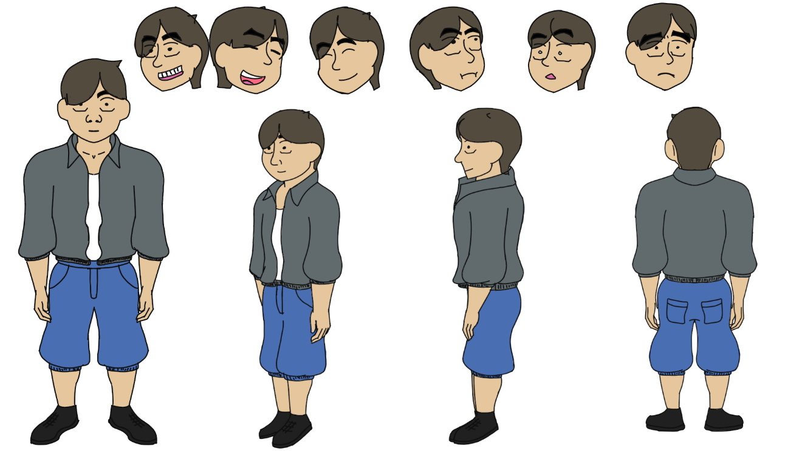

JAMAL: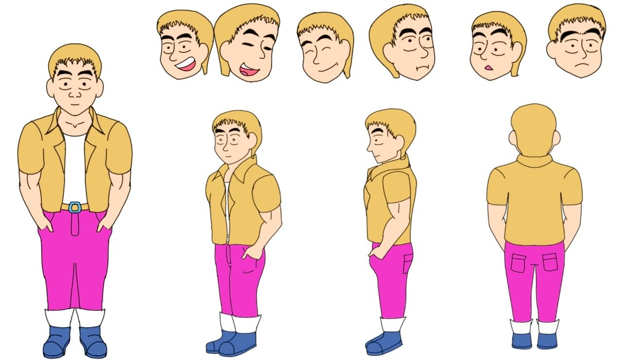

-Description of every character:
1. Luka- the protagonist
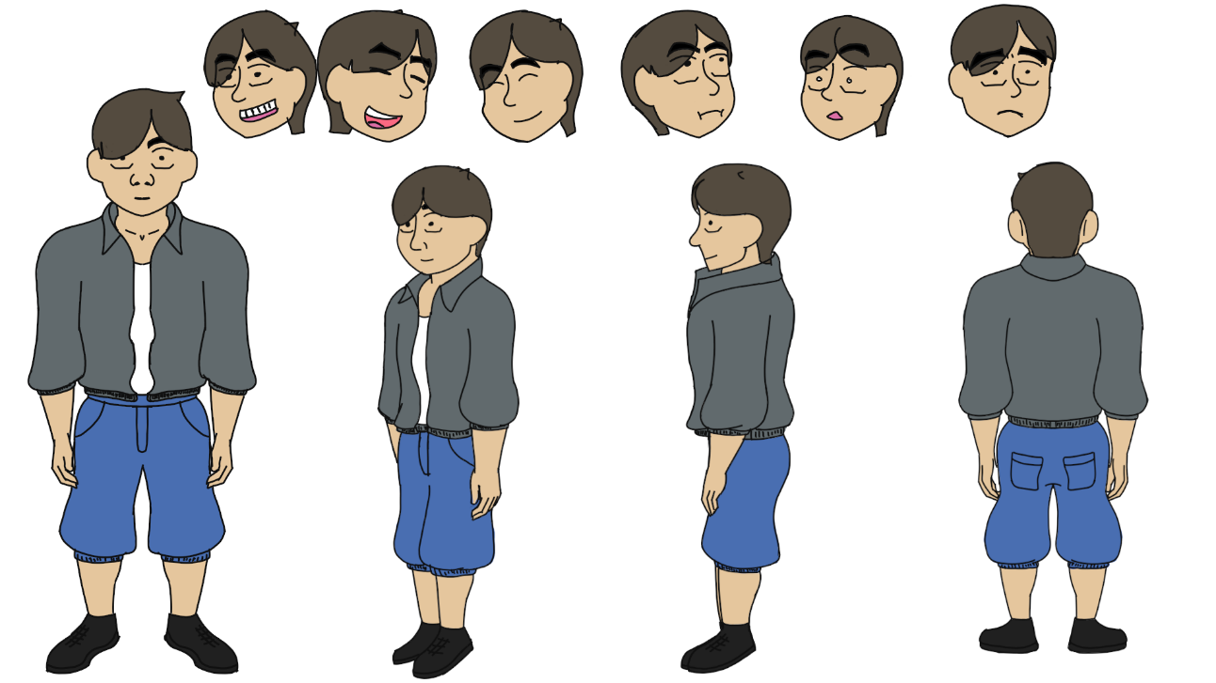
-Background: A young boy who’s ongoing but can be also easily influenced if pressured or persuasion. He’s also the protagonist who got addicted to playing computer games because he got influenced to do it by his best friend.
-Role: He’s the protagonist of the film.
-Personality: Cheerfull, friendly, and ongoing.

2.Jamal - Side Character


-Background – The boy who’s influenced the protagonist to play computer games that let to the protagonist change of fate.
- Role: Side Character of the protagonist and his friend.
-Personality traits: Jamal is the mischievous one, he refuses to learn, and he is only interested in his hobby which is playing computer games. And the one led the protagonist to change his ways.
Together with the persuasion of Jamal, Luka changed his ways and explored the joy of playing computer games, but with the consequences if the hobby was the reason why certain ways can be changed drastically.

Staging and Layout Themes and design of the Scenes

In “The Game Boy”: It is highlighted that Exaggeration, Anticipation, Composition, etc. are essential/crucial in storytelling and enhancing the overall flow of the animation here are the used principles of animation.

1.Exaggeration: Type of animation used in making some actions over the line lines the word exaggeration it is also used in our animation to showcase our characters overreact on certain things to make them more understandable and to add some better illustrations on the characters behaviors.

2.Anticipation: The best type to illustrate showing predictability on certain actions to better prepare audience on what the object or character was about to do more like preparing them, it is also used in our animation to show some predictability on some action and stuff that was about to happen.

3.Composition: Commonly used in animation to better showcase the atmosphere or the background on the scenes present and better proof on what position was placed or being seen, this is also our main element used in all our scenes to better describe the scene.

4.Staging: Essential elements used to highlight where, does it happen? When did it happen, and what are the things present there. And clear things up like the background, camera position, and foreground. It is used in our animation to just focus on what’s happening and avoid confusion or unnecessary distractions that may hinder the understanding of the scene.

5.Timing and Rhythm: If used properly can be the most crucial part of animation due to its elements that can dictate on the rhythm of certain scene like if a person is running then the speed of frames should be fast some sort like that. And the is a must principle we used in our animation due to it showing all scenes with their perspective rhythm on how the story flows.

6.Appeal: Appeal is the way to describe the character’s personality and its traits by showcasing how he looks, wears, and its movements. We also use it to better illustrate one’s characteristics.
All of that was applied to our capstone to enhance and better visualize our story to be understandable and impactful.

Layout Scenes:
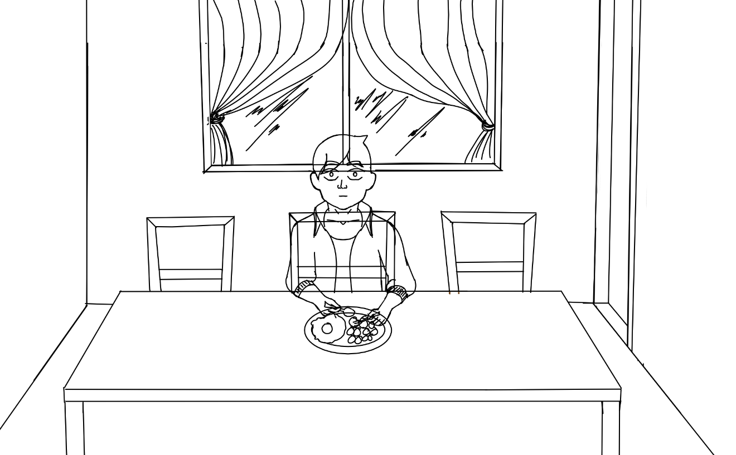
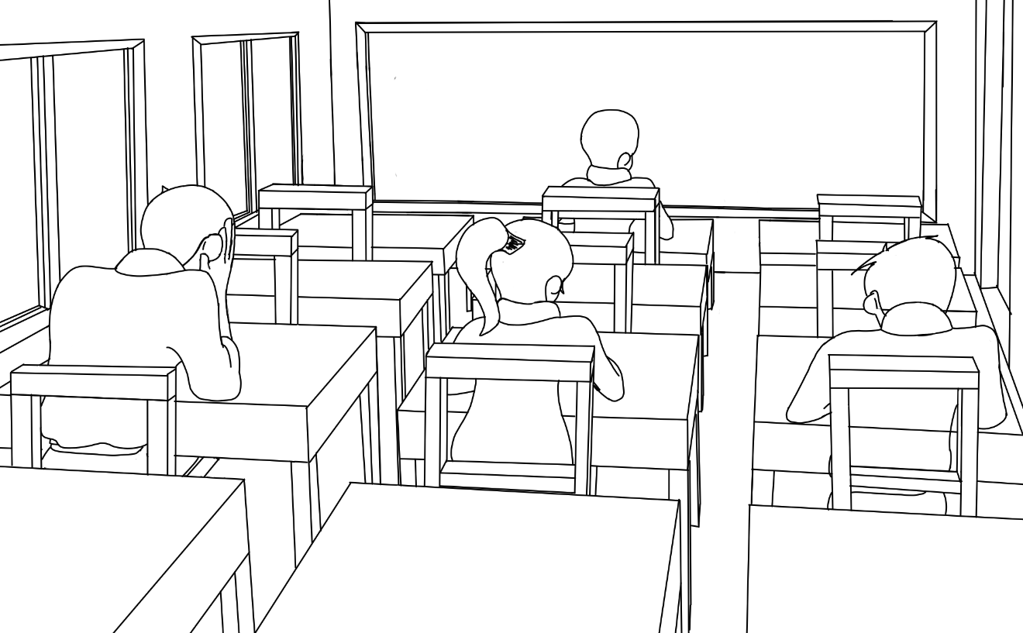

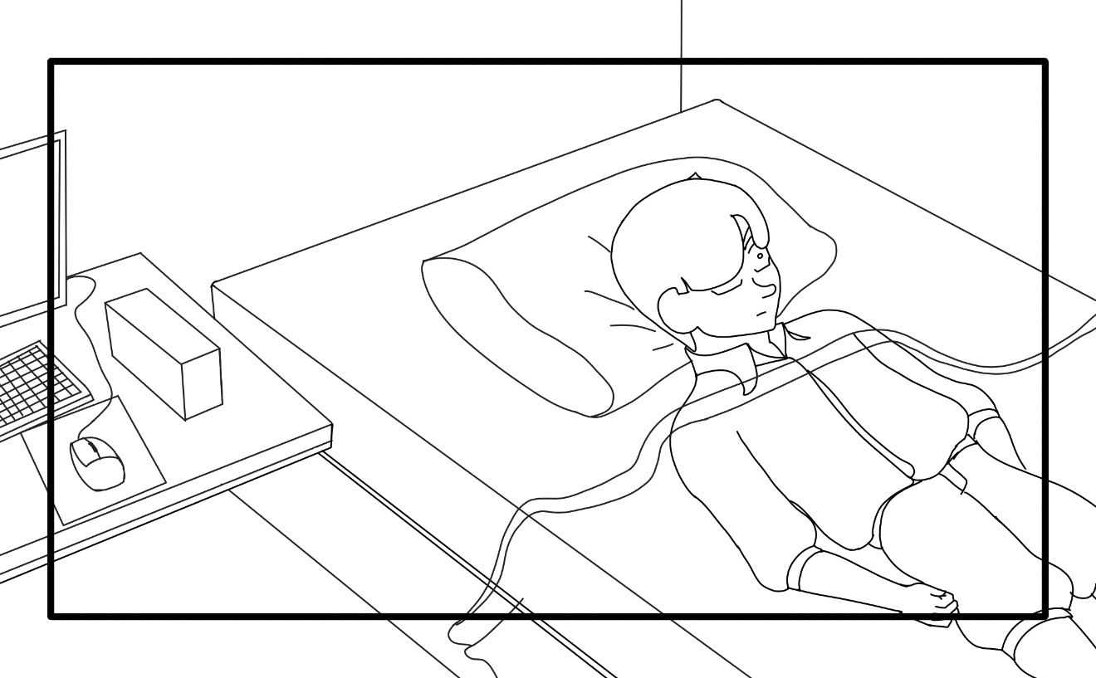

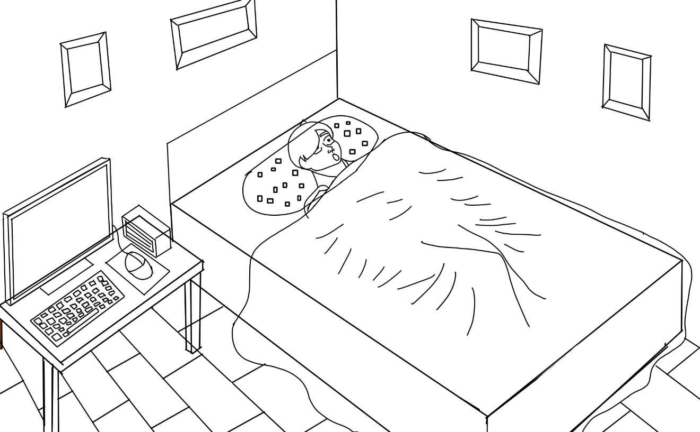
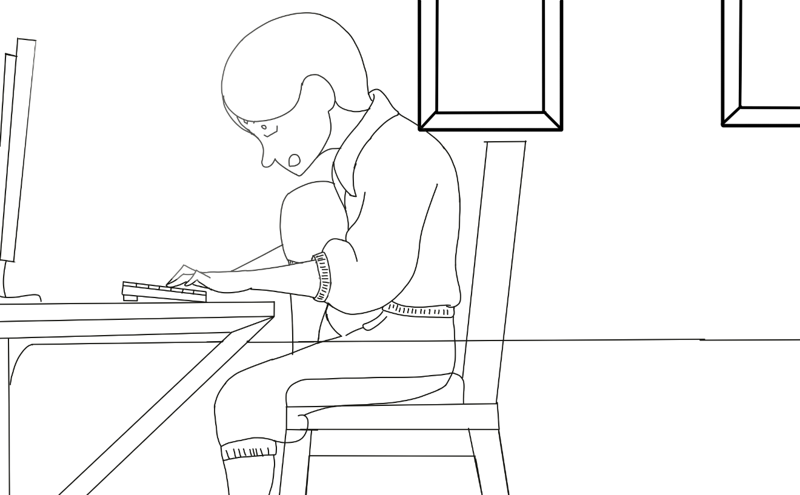
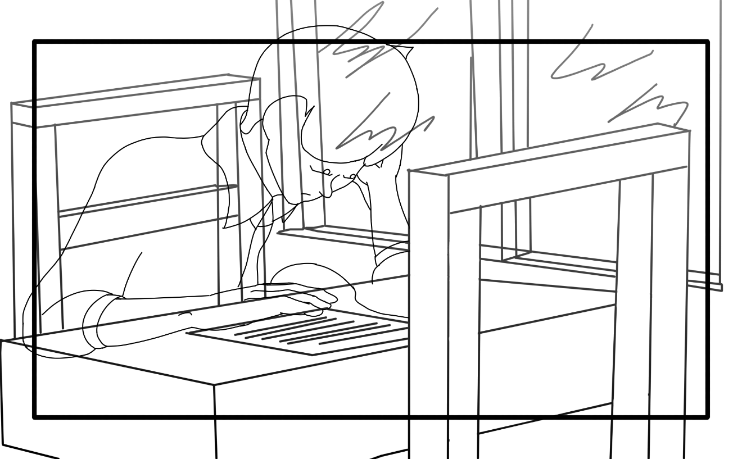

Camera Angles:
- Wide Shot
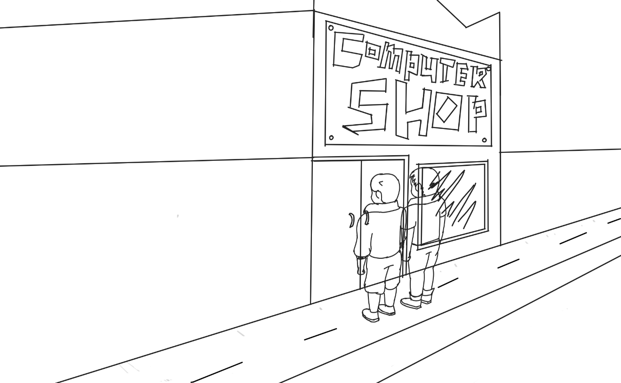

- Bird’s eye View
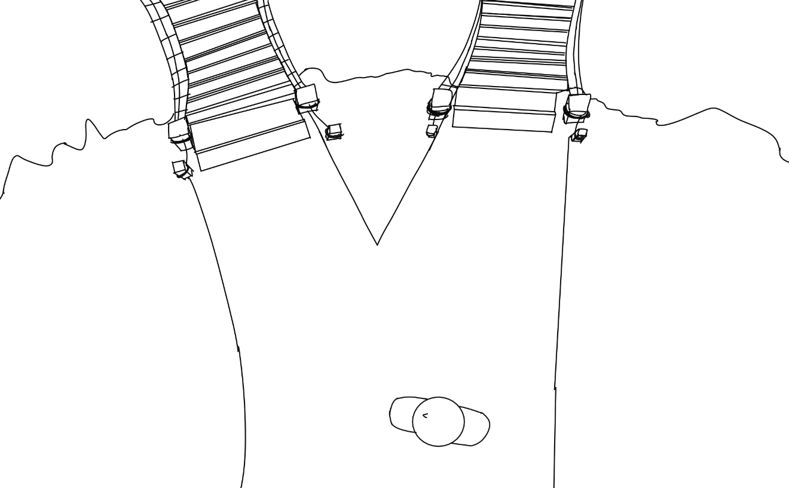

- Close Up
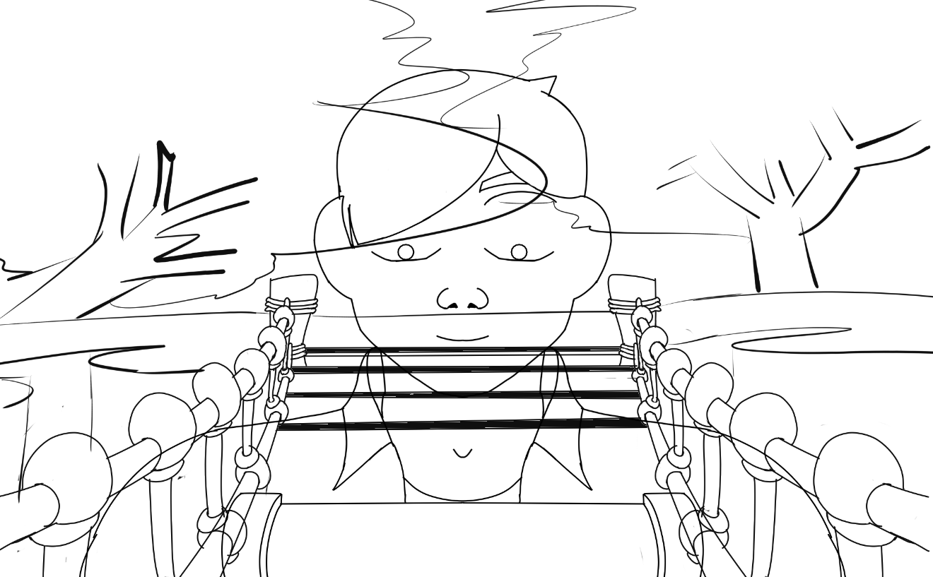
- Extreme Wide Shot
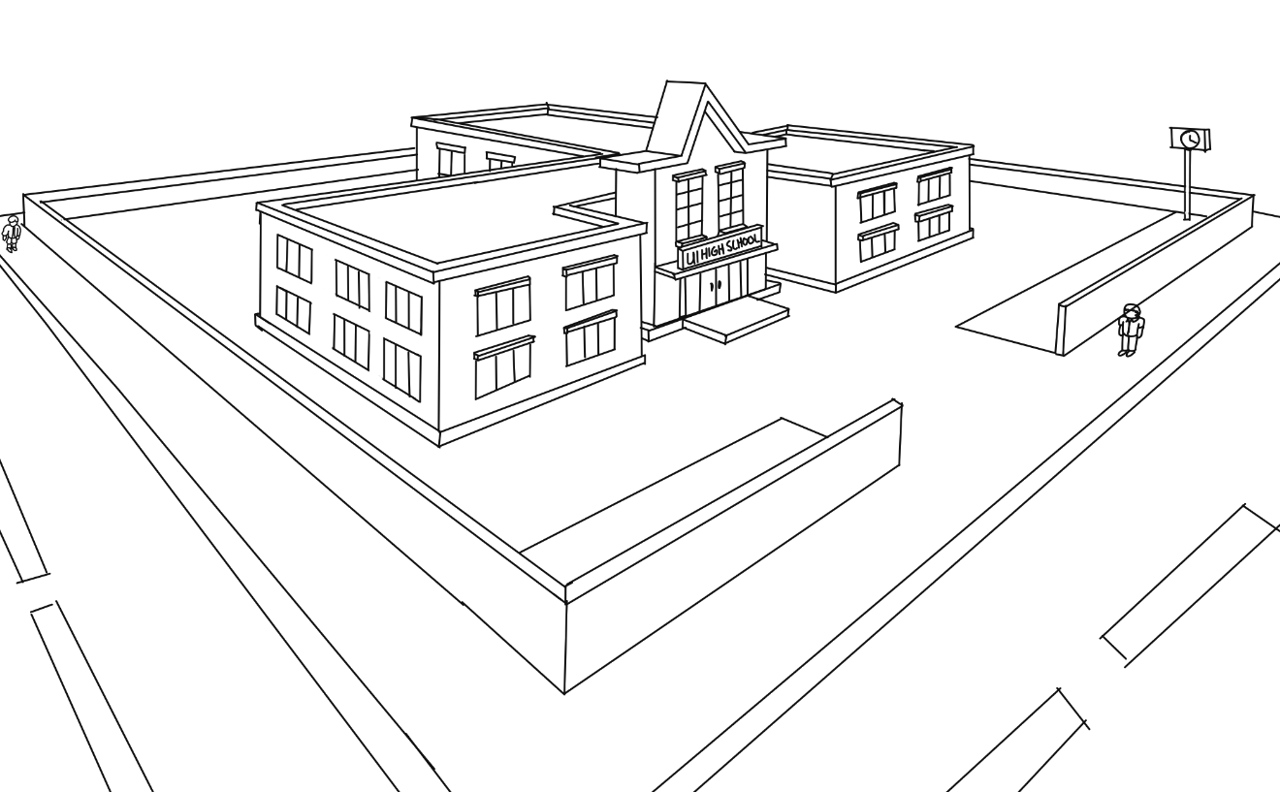
Character designs and Action poses:
- Rough
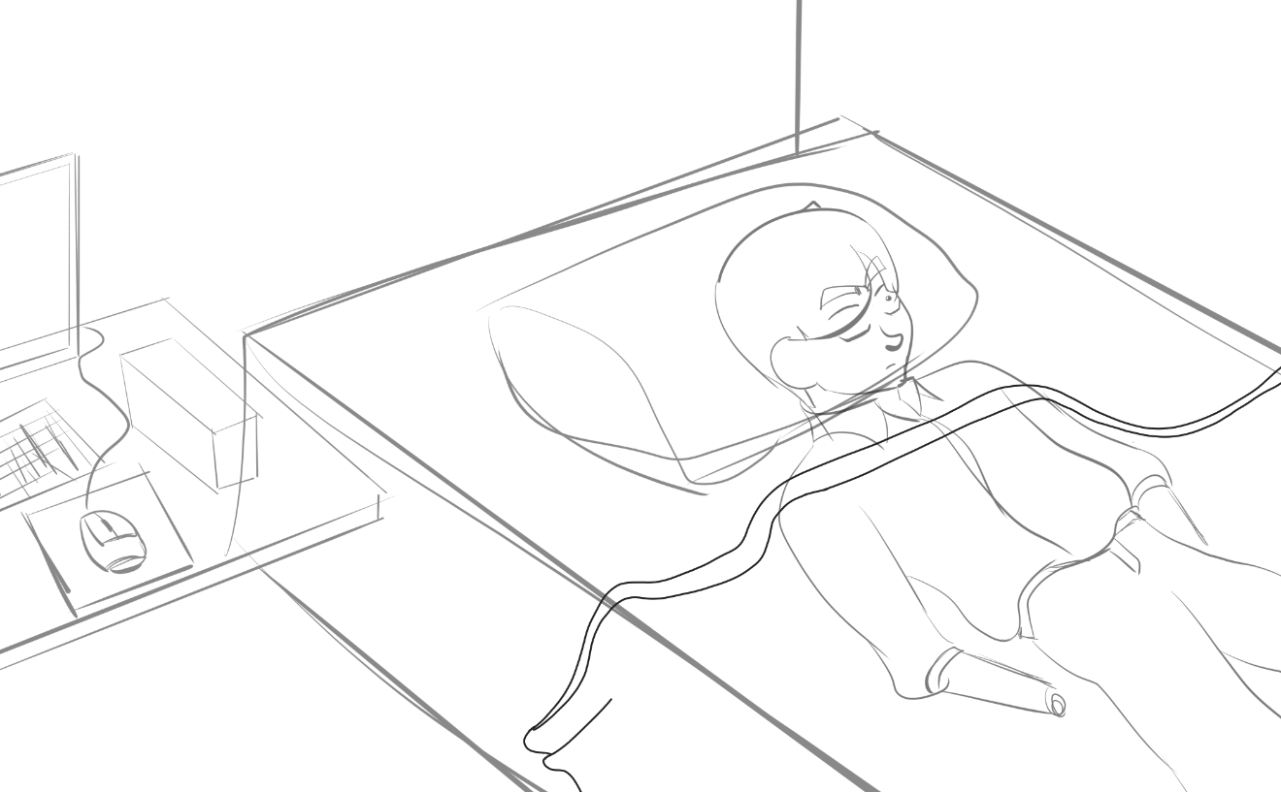
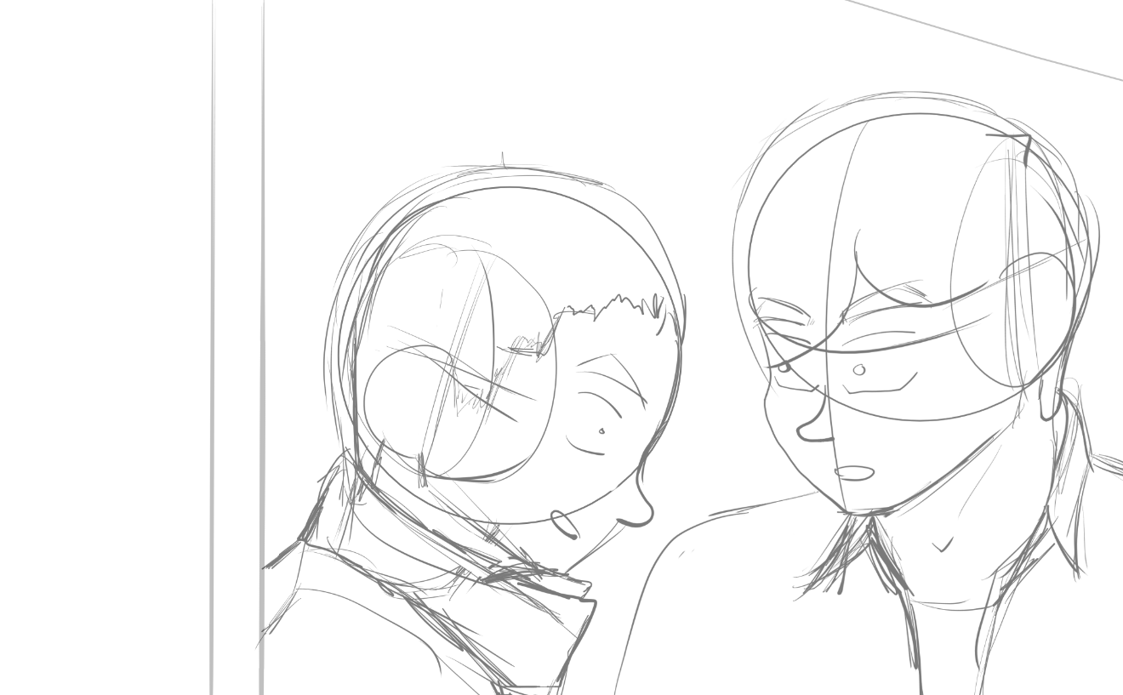
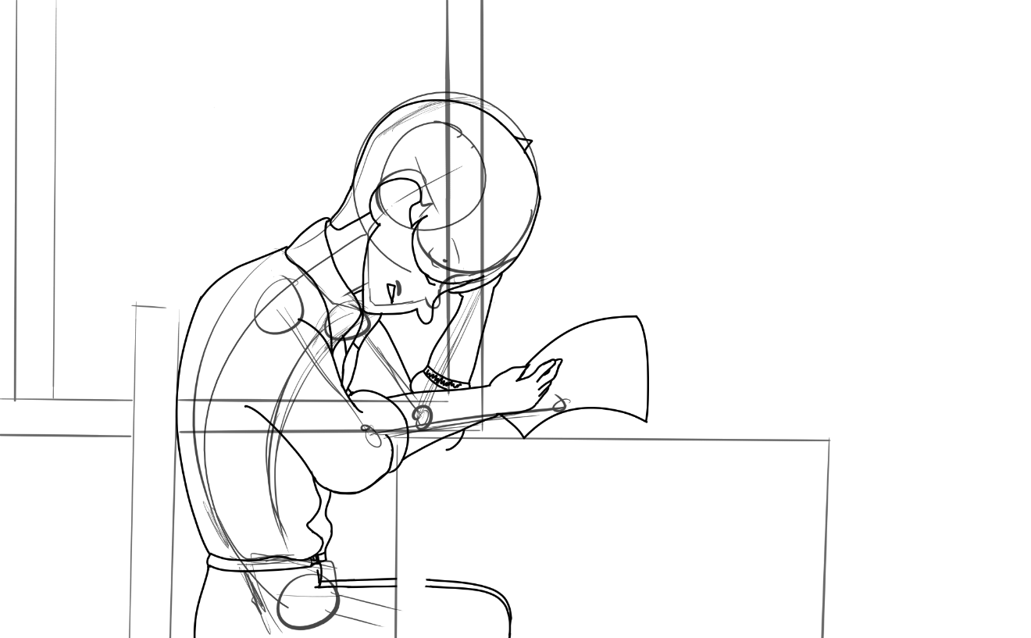
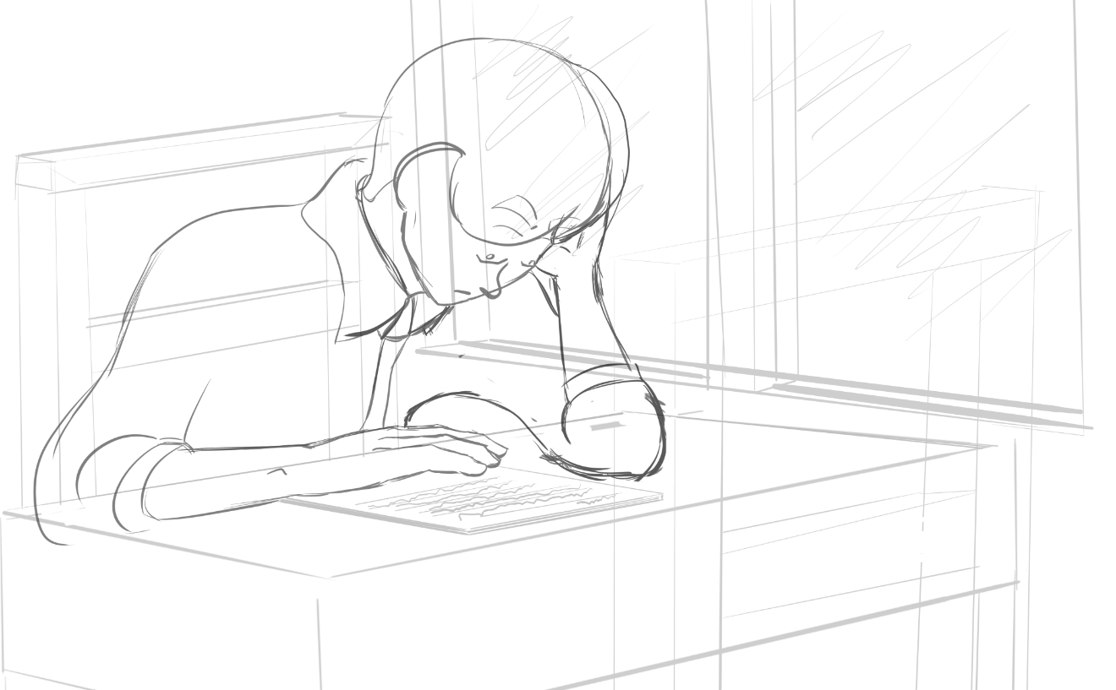
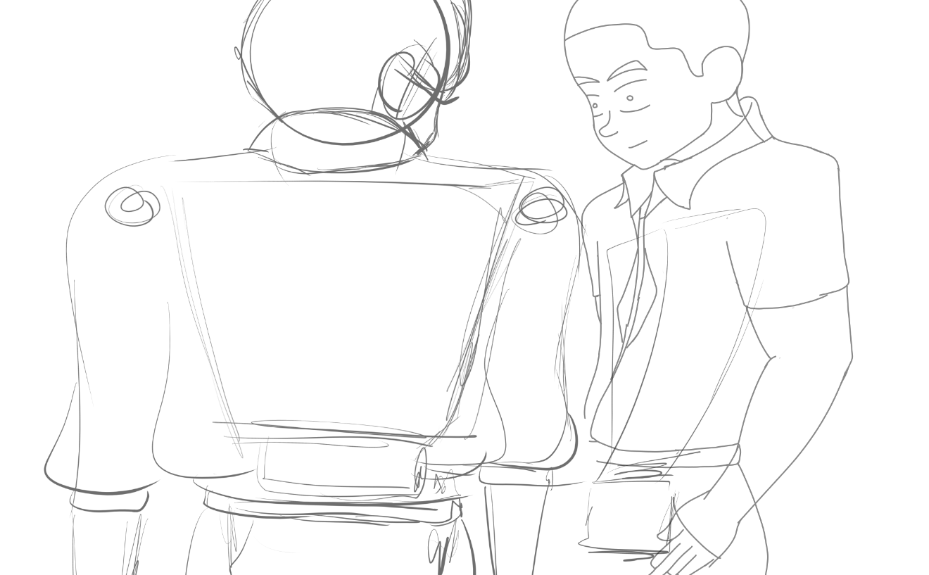
- Cleanup
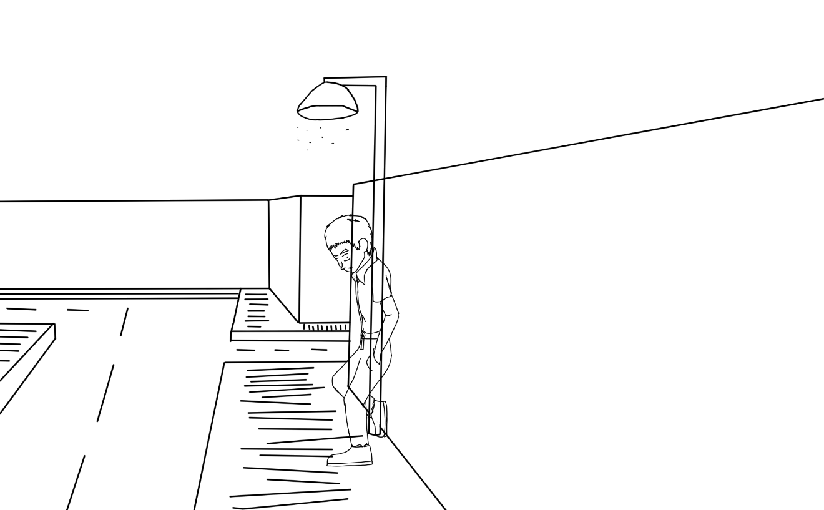
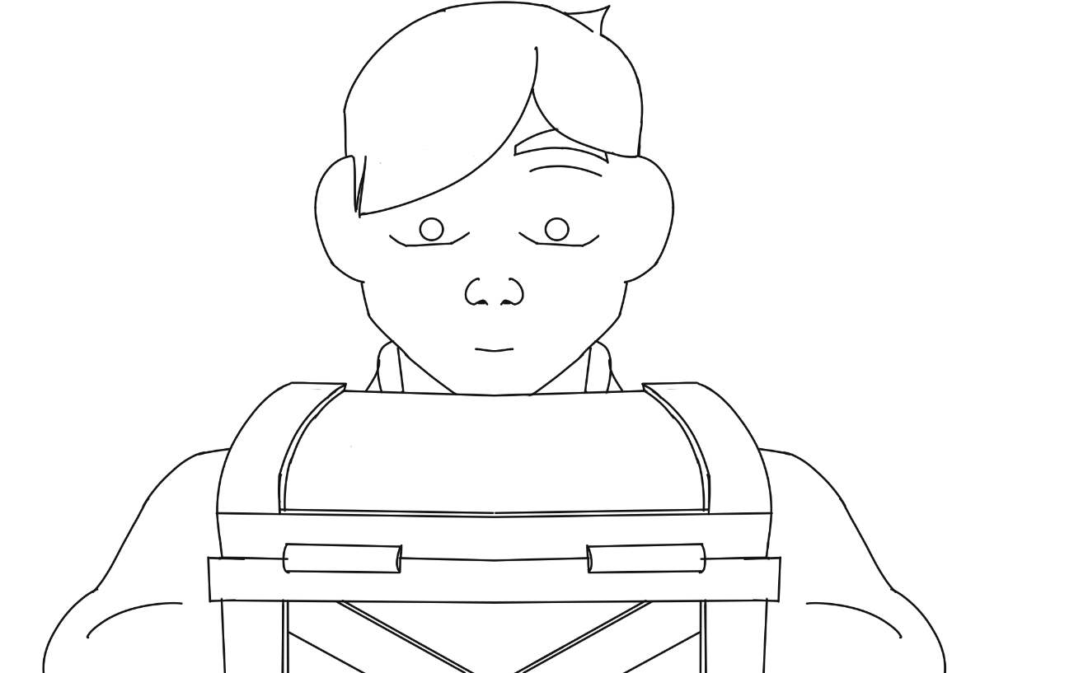

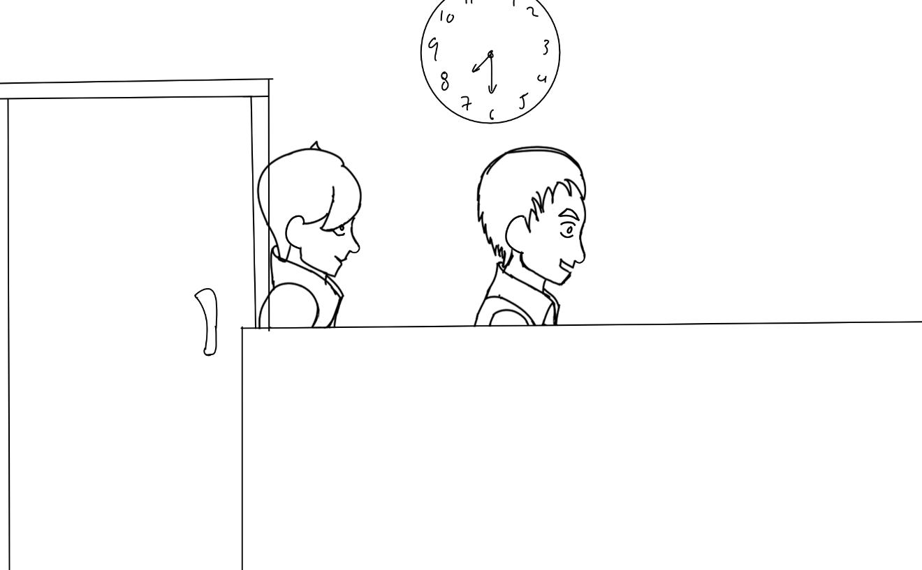
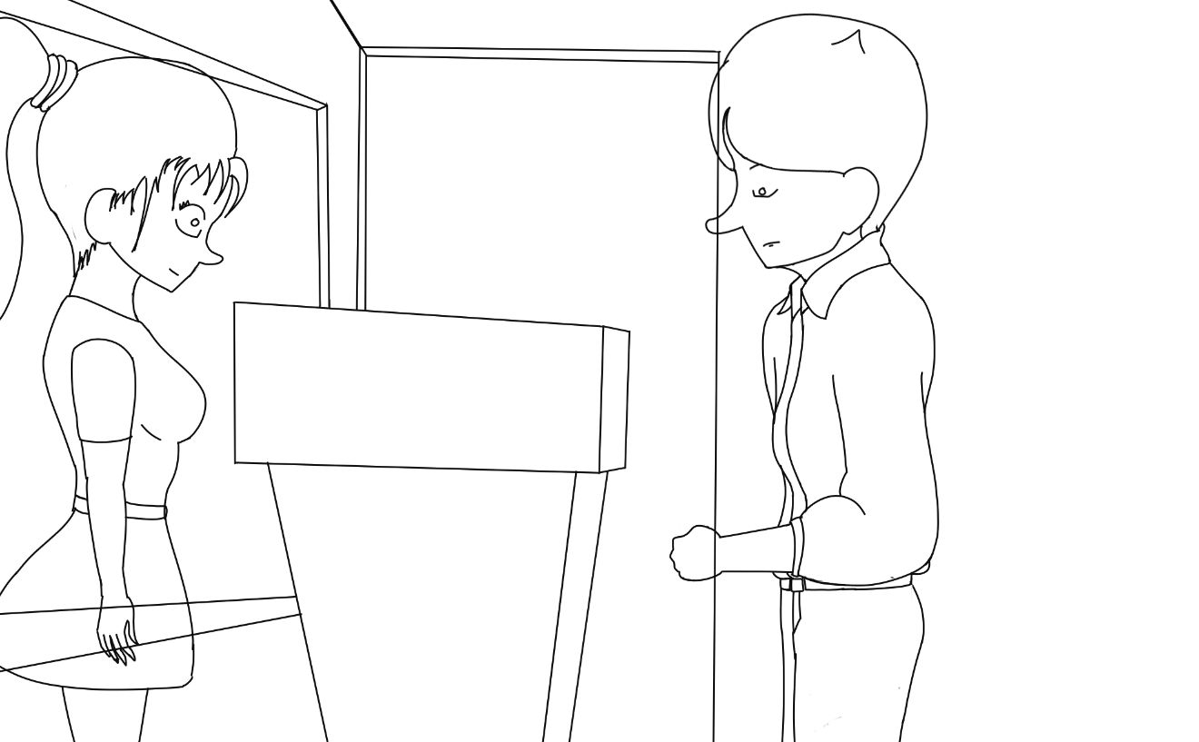

In Between Sample:
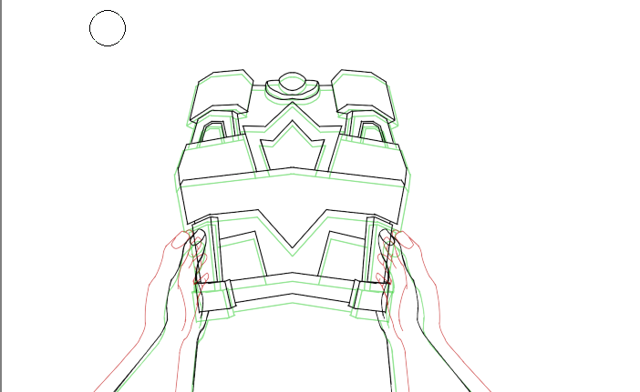

Storyboard Samples:
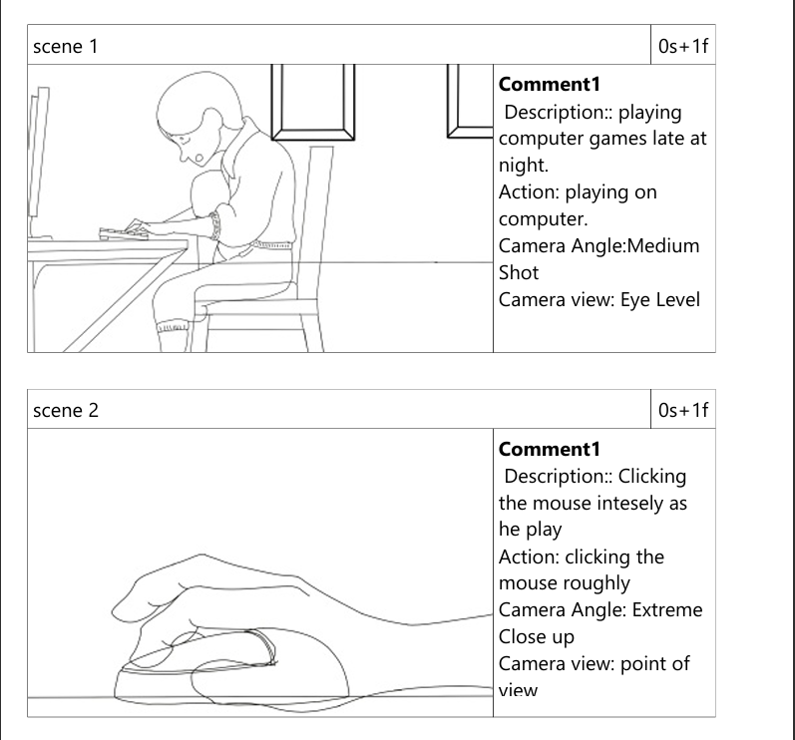
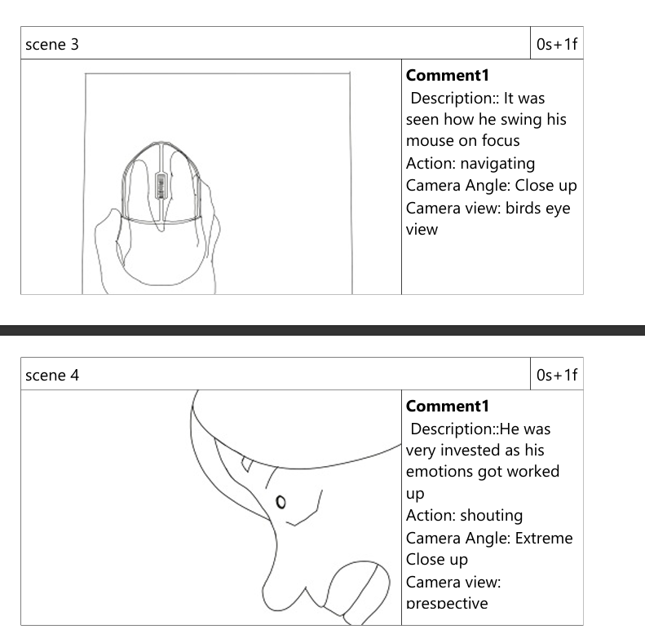
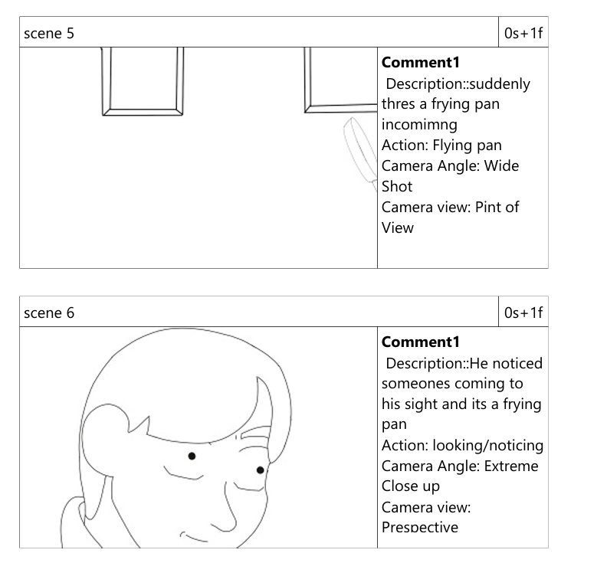
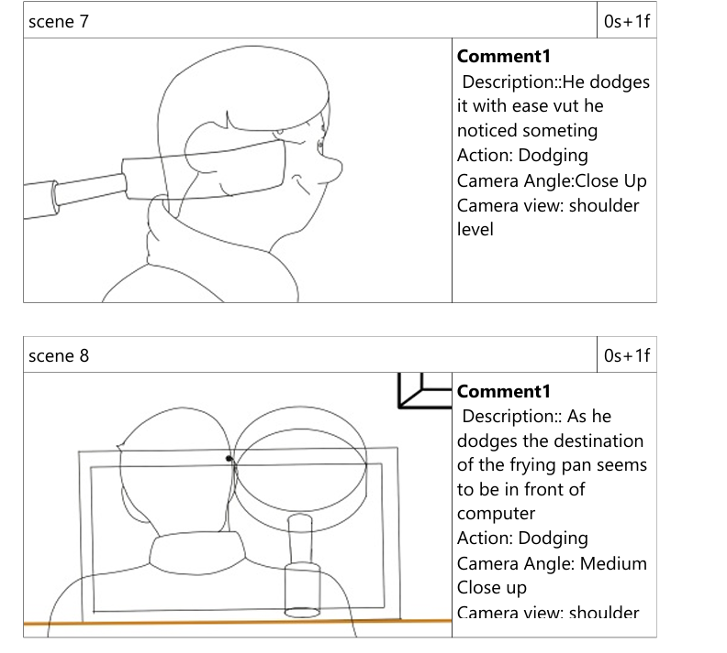
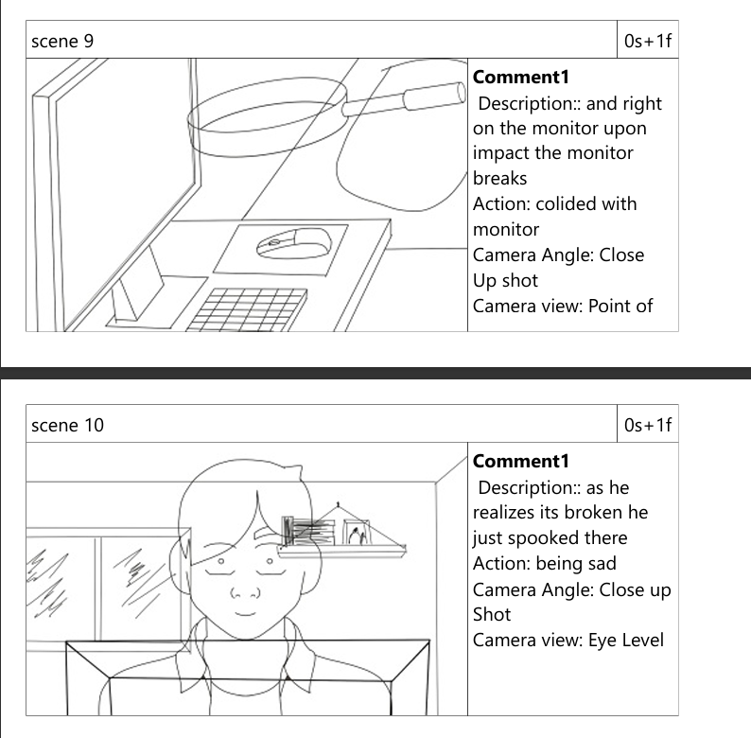
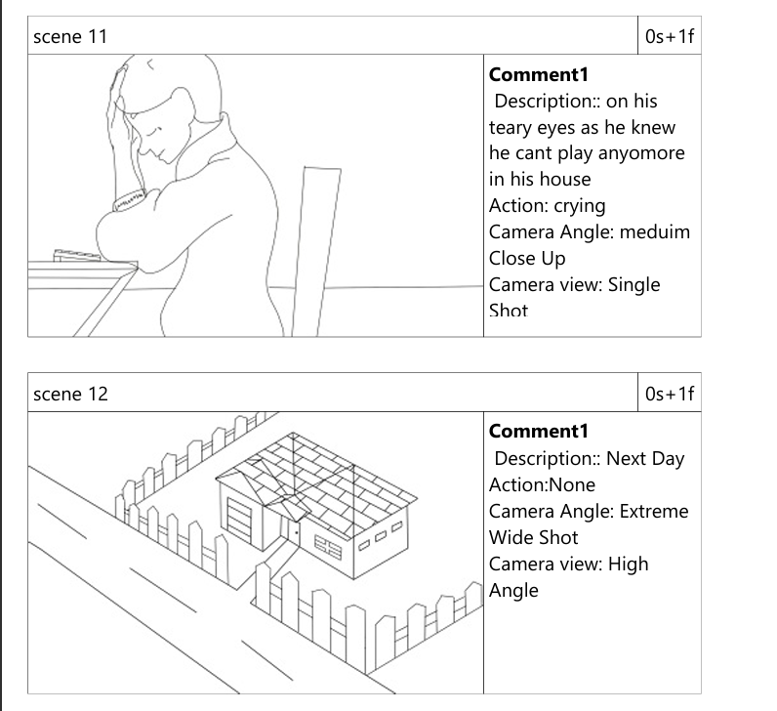

Clean Up Sample:
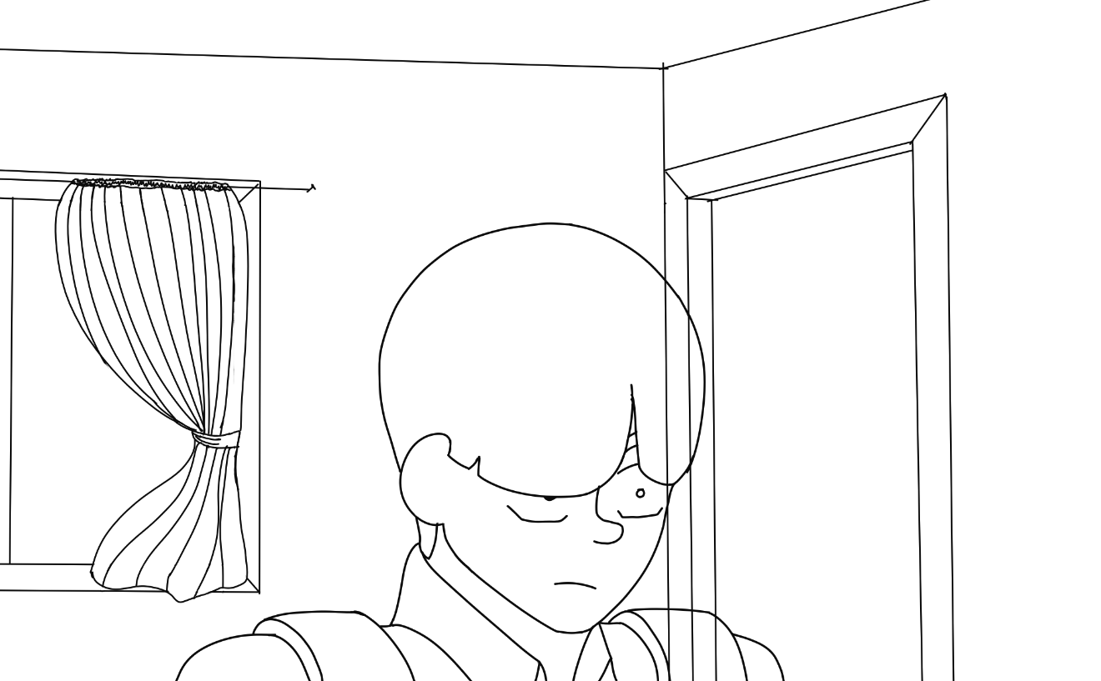

Background Scenes Samples:
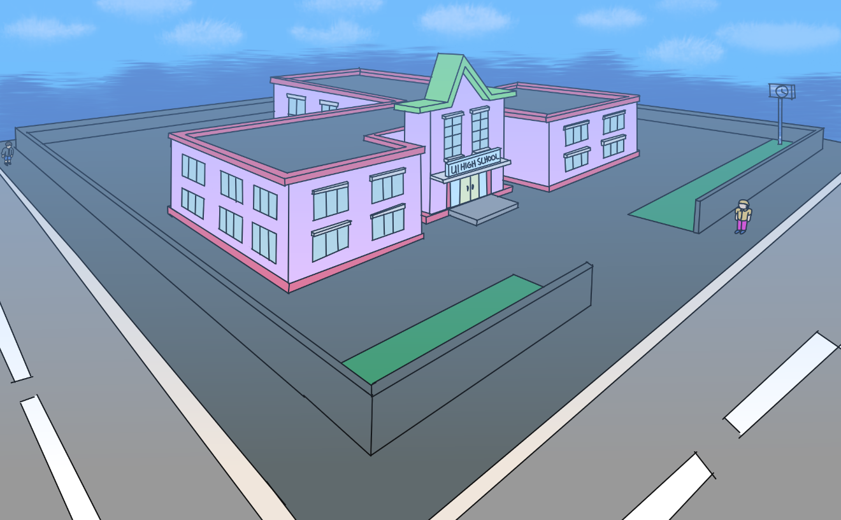
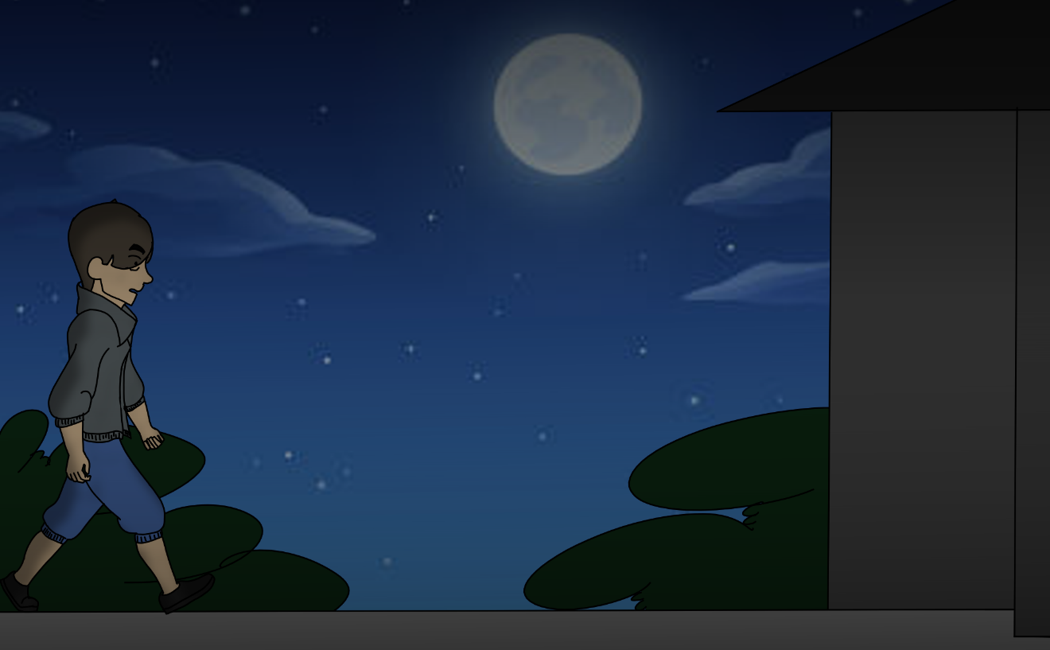
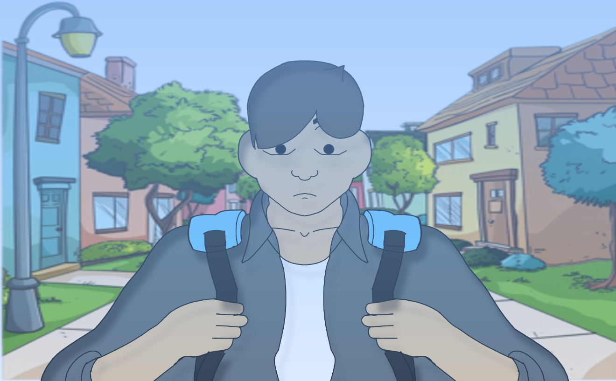
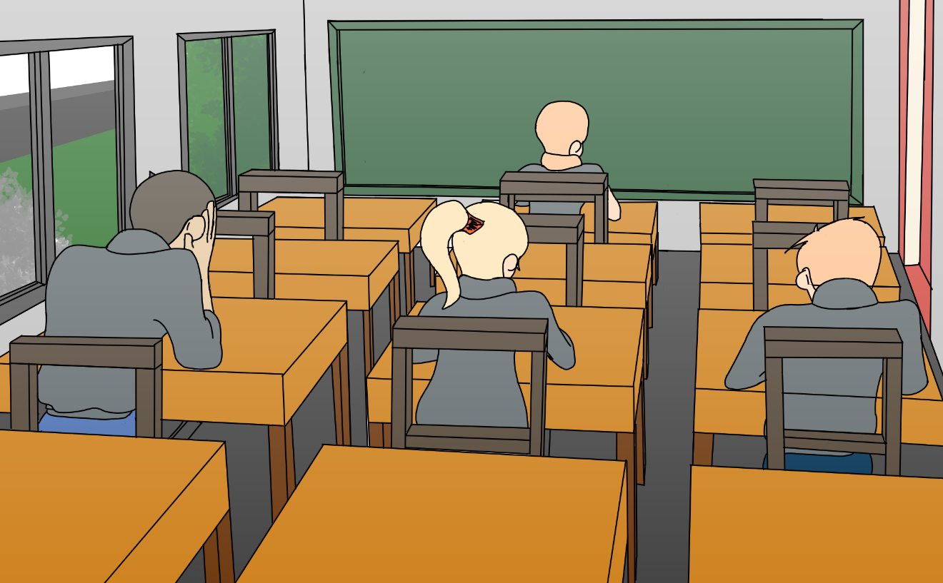

Mouth Chart:
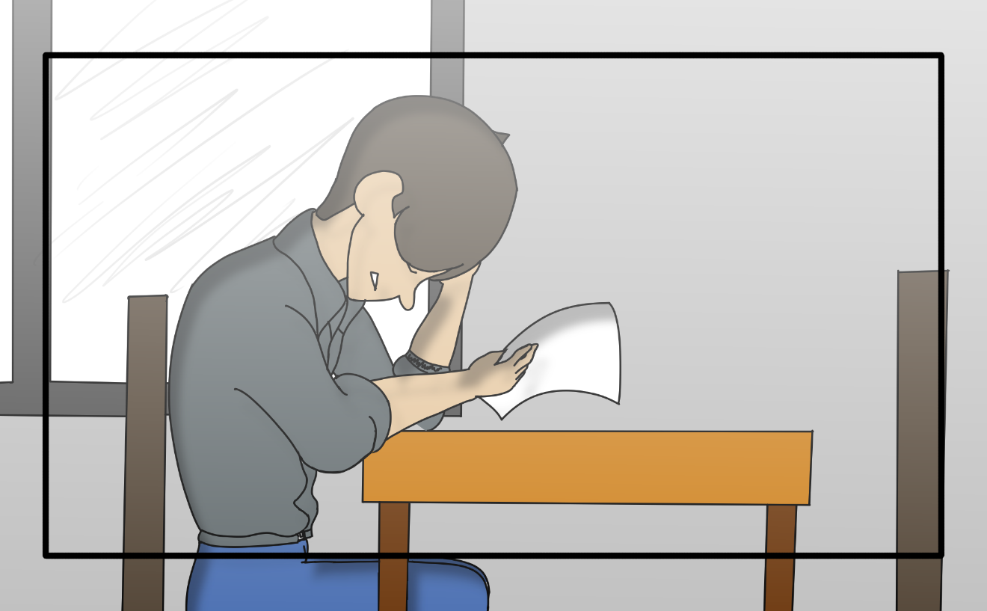

Sound: Since we followed a rule of “Show no Tell” expect that there’s no single dialogue present. But in exchange we Soley focuses on sound effects and music to tell or express the story from start to finish. Through that we can also implement the body language technique where body tells without the need of a single dialogue. Which a great alternative to a speaking person.

Production Process: With the rule “Show no Tell” we focused on enhancing the overall effects and visual presentation of the story, Like adding shadows, lightings, Background details, and more to express it more through the atmosphere of the background or the sound effect used in that particular scene.

Challenges: On production phase we encounter a huge challenge in creating and developing our film and that is to add dialogue or someone speaking since our film was good if it has a dialogue present since its about the message it will deliver to the audience.
To find a alternative we use “Body Language” why use body language? Since most people understand body language more than actually someone’s speaking its because with body language your body actually being honest with its movements towards a person or environment. And that’s how e come up with the alternative for dialogue.

Target Audience: Our Target audiences are everyone why?
Since the film is about awareness its better if any age can watch the film so that they have even the slight hint on the effects or consequences of excessive gaming to a person.

CHAPTER V
Conclusion:
Overall, “The Game Boy” has been a great initiation to unlock and discover skills in different ways possible and why is that? Since it’s a capstone project which is something you should be focusing and work seriously it lets us to do things that we cant do from the past which is improve, from time to time while working with our animation along the way we learn and discover new things that we can apply to further make our animation better whether it’s a simple redo of a characters movement to a better and clear placing of every character, background, camera angle, and lastly its lighting and shadows, which make every scene understandable.

Summary:
“The Game Boy” Is a capstone project which was task to us to create. The project needs planning, composing, brainstorming every scenes on what should be its position, where does it happen, what time, and what did they do. Additionally from creating a storyboard which is the initial clue on what will happen it that scene.

Together with adding atmosphere of the background, lighting, and shadows that makes our animation more visually appealing, added to that the timing of composition from the frame speed, transitions, and the sound effects and music used that makes it more better overall.

Overall “The Game Boy” serves a great way to not just create a animation but also develop, and discover something that proves helpful while developing our animation. And by the end of this production we learned that every step of developing a animation should be carefully planned. Understanding the story you’ve created also helps you to better come up with ideas on what to add and compose in every scene, everything we learned from this will prove useful in the future.

